A Rural Cooperative Recycling Tool Kit:

Regional Purchasing,
Recovery, Processing
and Market Development

Prepared for the
Del Norte Solid Waste Management Authority

Prepared by the
Rural Counties Environmental Services Joint Powers Authority

In cooperation with
Del Norte County
Humboldt County
Center for Environmental Economic Development

April 2002
A Rural Cooperative Recycling Tool Kit:
Regional Purchasing, Recovery, Processing
And Market Development

Summary

Date Published: April 2002

Description:
This model tool kit provides rural jurisdiction with an evaluation process for the development and implementation of rural cooperative recycling solid waste diversion programs. The unique challenges faced by these communities have increased since the passage of the Integrated Waste Management Act of 1989 (AB 939). Cooperative recycling between jurisdictions may provide a means of overcoming many of the barriers to cost effective diversion programs in rural areas. There are many ranges of cooperation that can be used. This Tool Kit provides a methodology for rural jurisdictions to evaluate the current solid waste infrastructure in order to identify potential discarded materials that are candidates for diversion. Potential activities and resources are presented that can assist in developing programs and markets for these discarded materials.

Many of the concepts presented in this Tool Kit are based upon the joint efforts of Del Norte and Humboldt Counties in development and implementation of their “Regional Purchasing, Recovery, Processing, and Market Development Plan”. The Del Norte Solid Waste Management Authority contracted with the Rural Counties Environmental Services Joint Powers Authority (ESJPA) to develop this Tool Kit for the benefit of its twenty-one member counties and other rural California jurisdictions

The original document was printed on Eureka 100! containing 100% post-consumer fiber content and is chlorine-free and acid-free.

Table of Contents

Executive Summary 1
What Does Rural Mean? 3
What is Rural Cooperative Recycling? 4
How Can You Cooperate? 6
Part One: Review and Analysis of the Current Recycling Infrastructure 8
Determining the Amount of Waste Generated 9
What is a Waste Generation Study? 9
Characterizing Waste Disposal 11
Measuring Diversion 11
Reviewing Original Base-Year Data 12
Revising Base-year Generation Data 13
Reviewing Annual Report Data 14
What Does all of this Data Mean? 14
Conducting a Voids Analysis 17
What is a Voids Analysis 17
Steps to Conducting a Voids Analysis 19
Identifying Potential Market Incentives 25
Calculating Economic Feasibility 25
Determining Existing Markets 27
Identifying Economic Development Incentives 28
How to Determine General Trends in Reuse, Composting, and Recycling 30
Summarizing Market and Incentive Information 32
Assessing Rural Transportation Options 33
What is the Current Rural Transportation System 33
Finding Transportation Opportunities 36
Review of Back-haul Options. 36
Review Humboldt/Del Norte Transportation Cost Model 38
Part Two: Developing Activities, Programs, Resources and Options 39
How to Sponsor an Innovators Forum 39
What is an Innovators Forum? 39
Types of Innovators Forums 40
Examples of successful Forums 41
Suggested Forum topics for rural counties 41
Using The RecycleStore as a Marketing Tool 43
What is the Recycle Store? 43
Finding Products to Include in the RecycleStore 43
How to Use the RecycleStore 44
Taking Advantage of Recycling Market Development Zones (RMDZ) 45
What is the RMDZ Program? 45
Identifying Opportunities for Expanding Rural RMDzs. 46
Sharing Resources With Your Neighbors 47
How to Promote Government Purchasing for Waste Reduction 50
Determining Your Potential for Recycled-content Procurement 50
How to Develop Regional Agreements 53
How to Identify Potential Regional Opportunities 54
Cooperative Regional Agreements 55
Putting all of the Pieces together 57
Acknowledgements 58

Appendices

- Waste Generation Data
- California Integrated Waste Management Board – Planning Annual Report Information System Codes
- Innovators Forum
- RecycleStore.com
- RMDZ Application and Information
- Waste Reduction Program Evaluation
- Procurement Policy Samples
- Sample Regional Agreements
- Glossary

List of Figures

- Types of Cooperation
- Generation, Diverted, and Disposed of Materials Table
- Generation, Diverted, and Disposed of Materials Chart
- Waste Generation Data Sample
- Goals of a Voids Analysis
- Conducting a Service Voids Analysis Flowchart
- CIWMB Sample Paris Notes
- Sample Voids Analysis
- Summary of Service Voids and Opportunities
- Regional Voids Analysis Considerations
- Basic Model - Condition for Feasibility
- Historical Prices for No.6 Newspaper
- Tuolumne County CalMax Case Study
- Regional Purchasing Cost Savings Example
- Environmental Services Joint Powers Authority Counties Map
- State of California, Department of Transportation Truck Networks Map
- ESJPA County Groupings
- Process for Analyzing Transportation Costs
- Types of Innovators Forums
- RecycleStore Products
- Methodology to Determine Shared Resources
- Coordinating Government Procurement
- Solana Recyclers
- Types of Regional Agreements

Executive Summary
Rural jurisdictions face unique challenges in the development and implementation of solid waste diversion efforts. The passage of the Integrated Waste Management Act of 1989 (AB 939) increased these challenges by requiring jurisdictions to develop and implement programs to divert fifty percent of their wastes by the year 2000. Some of the challenges facing rural jurisdictions include: distance between generators and markets, seasonal fluctuations, lack of staff and funding, limited economy of scale, high collection costs because of dispersed populations, low tax base for funding programs, and the potential for improper disposal of wastes on large tracts of public land and along roadsides in remote regions.

This Rural Cooperative Recycling Tool Kit is designed to provide tools for rural jurisdictions to use in the development of cooperative recycling efforts. Cooperation between jurisdictions may provide a means of overcoming the barriers to diversion programs. Cooperation can range from sharing experiences, using another jurisdiction’s educational or organization information and coordination techniques, to the development of mutual programs and contracts with the sharing of costs, staff, equipment, and more

This Tool Kit builds upon the joint efforts of Del Norte and Humboldt Counties preparation of a “Regional Purchasing, Recovery, Processing, and Market Development Plan for Del Norte and Humboldt Counties. Many of the concepts presented in this Tool Kit were developed through the efforts of this Cooperative Regional Plan, which should be used in conjunction with this Tool Kit. The Del Norte Humboldt County Plan provides a case study of the efforts of two rural joint powers authorities to enhance their information and recovery programs by expanding cooperative regional efforts.

The Rural Counties Environmental Services Joint Powers Authority (ESJPA) was contracted to prepare this document for the Del Norte Solid Waste Management Authority as a component of a contract that Del Norte received from the California Integrated Waste Management Board.

The ESJPA is a 21-member association of rural California counties. The ESJPA is comprised of the following counties: Alpine, Amador, Butte, Calaveras, Colusa, Del Norte, El Dorado, Glenn, Inyo, Lake, Lassen, Mariposa, Modoc, Mono, Nevada, Plumas, Sierra, Siskiyou, Tehama, Trinity, Tuolumne. The ESJPA provides technical assistance to rural counties, supports local public education campaigns, and administers grants for recycling and hazardous waste management programs. This Tool Kit includes information from the rural county members. The experiences of the ESJPA counties are likely representative of the experiences of other rural areas.

Existing data from ESJPA member counties have been reviewed and analyzed to present the current infrastructure in these rural counties. Activities, programs, resources, and options are presented that rural counties can consider in developing cooperative marketing.

The first part of this Tool Kit provides jurisdictions with a plan for assessing the amount and types of potential materials for diversion efforts; how to determine what voids exist in the existing infrastructure; identifying potential market incentives; and, assessing rural county transportation options. The result of this review is to provide jurisdictions with information to help target a material or materials for development of diversion programs.

Once materials have been selected for cooperative recycling efforts, the second part of this Tool Kit provides jurisdictions with assistance on developing activities, programs, resources, and other options for diversion of that material. Specifically, information is provided about how to sponsor an Innovators Forum, using the RecycleStore as a marketing tool, how to promote government purchasing for waste reduction, taking advantage of Recycling Market Development Zones, and how to develop a Regional Agreement.

This Rural Cooperative Recycling Tool Kit can assist rural jurisdictions with increasing diversion through cooperative efforts. In addition, this Tool Kit will provide jurisdictions with an evaluation of their existing programs, opportunities for implementing additional diversion programs, and increased networking. This Tool Kit can also provide substantiation of current barriers to program development to assist in long-term planning efforts.

What Does Rural Mean?
Rural counties face many challenges in the development of cooperative regional recycling programs. The 21 ESJPA counties cover 52,656 square miles or nearly 34 percent of California and contain less than 700,000 people or slightly over two percent of California’s population. Most of the population of these counties is in one or two population centers. The total waste disposal in 2000 from these 21 counties is 786,283 tons or only 2% of California’s total 38.1 million tons. Despite this proportionally smaller amount of solid wastes, rural jurisdictions are generally subject to the same diversion mandates as urban communities.

The California Legislature and the California Integrated Waste Management Board (CIWMB) acknowledge these challenges facing rural jurisdictions in their definition of a rural area. California Public Resources Code, Section 40184 states that a city or county is a rural area if it is “located in agricultural or mountainous areas of the state and located outside the California Department of Finance’s Primary Metropolitan Statistical Areas.”

This recognition underscores the importance for rural areas to cooperate where feasible with other rural areas in order to increase the marketability of recyclables. The types of cooperation can vary depending upon program or situation

For purposes of planning and diversion requirements, the California Public Resources Code, Section 40184 and the California Code of Regulations, Title 14, Section 18775 states that a county is “rural” if the population of the unincorporated area of the county is 200,000 or less.

A city is defined as “rural”, in California Public Resources Code, Section 40183 and the California Code of Regulations, Title 14, Section 18775, if it has a waste disposal of less than 100 cubic yards per day or 60 tons per day and either a geographic area of less than 3 square miles or a population density of less than 1,500 per square mile.

Other characteristics of the ESJPAs 21 rural counties include a limited tax base and low employment. The entire taxable transactions for these counties are slightly over 3 million dollars or only 0.8% of California’s nearly 360 billion dollars of taxable sales. This low revenue base makes development of recycling infrastructure more difficult and increases the benefit of cooperative recycling.

This Tool Kit seeks to provide rural counties with a means to assess their current recycling infrastructure and provide a methodology to increase solid waste diversion efforts through the development of rural cooperative recycling programs. In addition, this analysis can provide a basis for additional program development in compliance with the California Integrated Waste Management Act (AB 939).

What is Rural Cooperative Recycling?
Rural Cooperative Recycling is a strategy whereby rural communities collaborate in the planning and/or implementation of their efforts to divert materials from the solid waste stream. The intent is to create a common bond to solve an agreed-upon problem through identifying common needs, establishing avenues for communication, and sharing resources.

The Rural Recycling Strategies: Cooperative Marketing Tool Kit states that:

A recycling cooperative consists of a group of individuals, communities or businesses of varying sizes and types, organized around a desire to maximize recycling efforts and improve local and regional solid waste management systems by creating greater opportunities with economics of scale.
A Recycling Cooperative can be structured formally or informally or can occur for a short time or over a longer duration. A Rural Recycling Cooperative is similar to the agricultural cooperatives functioning in many rural areas. Recycling cooperatives can be established as non-profit, public, or private. Non-profit cooperatives include both public and private members. Public cooperatives typically include city, county, or regional agencies. Private cooperatives include large and small businesses in the area. This Tool Kit focuses on public cooperatives, but the concepts can apply to all types of cooperatives.

The emphasis of cooperative recycling is on determining a structure or combination of structures that result in the implementation of diversion program for targeted materials. The cooperating jurisdictions must determine the balance between administering the recycling services locally versus expanding to a more regional approach. Some of the potential activities of a Rural Recycling Cooperative include:

- Combining diverted materials for greater volume and a marketing advantage
- Group contracting for processing or marketing services
- Sharing information and conducting research
- Increasing efficiency of transportation
- Monitoring market prices and specifications
- Sharing revenue and risk of market fluctuations
- Reducing risk by sharing resources (expertise, equipment, staff, contracts)

This Rural Cooperative Recycling Tool Kit focuses on cooperative recycling efforts that assist in recovery, processing, and developing markets for materials selected for diversion from the solid waste stream.

As cooperation can improve the efficiency of education and public information programs, this Tool Kit also indirectly addresses waste prevention or source reduction efforts to prevent the generation of waste. While most recovery or processing programs focus on developing cooperative recycling efforts for materials already present in the waste stream, education programs often include information on practices that improve on-site management, reduce hazards, or reduce waste generation. This Tool Kit is a means by which interested jurisdictions can assess their situation and determine what form of cooperative recycling is more advantageous.

How Can You Cooperate?
Types of Cooperation

1. Networking and Sharing information
The first level of cooperation is the informal sharing of information between staff. This can include periodic phone calls, conference calls, electronic mail and other e-communications, face to face meetings, and shared distribution of regional information. This level may also include sharing of publications, educational materials, requests for proposals, contract language, ordinances, and promotional materials to assist in the completion of similar tasks in neighboring jurisdictions This level does not usually require the signing of any formal agreements.

2. Coordination
This level involves the coordinated implementation of one or more projects. Such projects could include coordinated outreach programs, coordinated implementation of collection events or collection events or short-term project, such household hazardous waste collection events, America Recycles Day, Second Chance Week, or disaster response planning.

3. Collaboration
This level involves shared implementation of medium term projects, such as shared application and administration of grants, technical assistance for startup of a particular business or activity for regional benefit, shared resources such as interns, student assistants or Cadre of Corps members. This level of coordination may require coordinated release of separate but complementary requests for proposals, and the ability to sign short-term memoranda of understanding for the term of the specific project. An example of collaboration is this project, RCRIDP, the subject of this Report.

4. Consolidation
This level involves creation of an administrative structure with continuing capacity for sharing implementation of long term projects, investments, interdependent facilities, purchase and maintenance of shared equipment, interdependent collection and processing infrastructure or transportation networks. This level may require the ability to mutually sign long-term contracts or agreements, which equal the term of a contract or the lifetime of specific equipment or facilities. The RMDZ structure is an example of consolidation as is the ESJPA.

5. Unification
This level involves formation of a single entity with responsibilities delegated by the members for facilities, equipment, funds, and structures of all types, both physical and informational. This level would likely require very long-term agreements with the establishment of a single, comprehensive integrated waste management system. A joint powers agency for a single county may fit this description, although regional JPAs are more likely to function at the level of consolidation.

Source: Del Norte Humboldt Cooperative Regional Plan
Figure 1
Jurisdictions need to determine the type of cooperation most appropriate for their specific circumstances. The Del Norte Humboldt Cooperative Regional Plan identified the following types of cooperation that are described in the Figure 1:

- Networking and Sharing Information
- Coordination
- Collaboration
- Consolidation
- Unification

The Del Norte Humboldt Cooperative Regional Plan identified the following principles and policies for regional coordination and cooperation:

- Programs should be implemented at the local level whenever possible and cost-effective.

- Facilities and programs that are intended to serve the larger region should be jointly planned and implemented by all affected stakeholders.

- Other Regional programs and events should be jointly planned and implemented on an as-needed basis.

- Providing an opportunity for ongoing dialogue between city, county, and waste management authority integrated waste management staff for sharing information and ideas will reduce duplication and increase effectiveness at all levels of government.

- The effective implementation of regional programs depends upon the development and adoption of a workable administrative and funding structure.

An effective model program is the Bluegrass Regional Recycling Corporation modal, based in Lexington, Kentucky. It operates more as cooperative with government members and membership costs based on population, a cost per capita for the member jurisdiction. This membership entitles them to a range of services, and they call themselves “Affiliates”. The recycling operations have been designed for a several different tonnage levels and the jurisdiction is assisted in setting up the level appropriate to their size which includes center design and operation. The design has been standardized, with chosen equipment and supplies. This gives the cooperative an economy of scale purchasing power for containers, balers, shipping vans. An additional bonus is that the equipment can be more easily maintained because there is a shared maintenance system that is easier because the centers all use the same equipment - - parts, supplies, expertise of repair. The smaller centers feed into larger centers (hubs). When a center reaches a higher tonnage levels they can take the next developmental step, which is clearly defined.

The marketing of the materials is done from the headquarters of the cooperative, and all the members share the services and benefits. There is a large range of materials (32 different products sold) that would have been a difficult storage issue for smaller recycling centers, but because of the hub and spokes structure, the material is handled by moving the smaller amounts to the hub centers to consolidate. The overall benefits to the jurisdiction include a more predictable, simple, lower cost and risk arrangement with larger scale benefits.

The BRRC has started to take the intermediate market steps of making longer term supply commitments at a higher processed material level. One project is an operation to palletize plastic before sending it to their market. The backhaul would be recycled plastic lumber that would be available to the public works departments of member jurisdictions. These intermediate steps would be taken when tonnage reaches levels that make the investment of intermediate processing economically feasible with committed tonnage.

These principles and polices can provide rural jurisdictions with a framework on which to proceed in development of regional programs. Each jurisdiction should review these items and assess the type of cooperation that meets the needs of the involved entities and is most appropriate to the selected programs. In many cases, multiple types of cooperation can be used by the same entities for different programs. Jurisdictions should periodically reassess the application of these principles and policies and the types of cooperation as diversion programs develop.

Part One: Review and Analysis of the Current Recycling Infrastructure
The first step in the development of a Rural Cooperative Recycling Program is to review and analyze the current recycling infrastructure in order to determine the most suitable material or materials for cooperative recycling. This is accomplished by:

- Determining the Amount of Waste Generated
- Conducting a Voids Analysis
- Identifying Potential Market Incentives
- Assessing Rural County Transportation Options
- Developing Programs and Resources
- Putting the Pieces Together

The extent of this review will vary depending upon the amount of resources available. For example, rural jurisdictions do not typically have funding to conduct an extensive Waste Characterization Study that addresses seasonal fluctuations and statistically relevant sampling. A simpler, but less scientific or representative approach, would be to conduct a brief disposal survey (landfill or transfer station) and query the operator on waste types and volumes. Each characterization method has advantages and disadvantages that the involved jurisdictions must weigh in determining the extent of their review.

This assessment can also be conducted on future anticipated materials. For example, if a major development is planned, cooperative recycling programs can be established that will accept the anticipated construction and demolition materials.

Once this review is complete, the jurisdictions can start to develop programs to promote diversion of targeted material by analysis of the current recycling infrastructure.

Determining the Amount of Waste Generated
The California Integrated Waste Management Act of 1989 (AB 939) required jurisdictions to implement programs to meet diversion goals of 25% by 1995 and 50% by 2000 (California Public Resources Code, Section 41780). This Act required each jurisdiction to conduct a Waste Characterization Study to quantify the amounts and types of wastes disposed and materials diverted within the jurisdictions. The diverted and disposed amounts combine to establish a generation rate that is the base amount for measuring future diversion achievement. Jurisdictions were also required to provide a 15-year projection of solid waste generated, diverted, and disposed.

It is important to recognize that waste generation data is only an approximation of the types and amounts of the various materials in the waste stream. In order to obtain an extensive and statistically accurate Waste Generation Study, a jurisdiction would need to spend considerable time and expense. Fortunately, information is currently available to provide jurisdictions with sufficient data for generated waste types. Jurisdictions can also conduct limited Waste Generation Studies if resources and time allow. The overall intent is to obtain a reasonably accurate picture of the amount of material available in order to realistically select target materials for implementing diversion programs.

In addition to determining numerical compliance with California’s diversion mandates, Waste Characterization Studies can provide jurisdictions with information on targeting waste streams for diversion programs. Disposal data can indicate large quantities of wastes that are not diverted or additional amounts of wastes that can be integrated into existing diversion programs.

The first step to developing a picture of the current solid waste and recycling infrastructure is to determine the amount of waste generated within the cooperative region. This section addresses the following issues:

- What is a Waste Generation Study?
- Characterizing Waste Disposal
- Measuring Diversion
- Reviewing Original Base-Year Data
- Revising Base-Year Generation Data
- Reviewing Annual Report Data
- What Does All of this Data Mean?

Overall, Waste Characterization Studies can provide jurisdictions with an indication of the effectiveness of their current programs and the opportunities for future diversion.

What is a Waste Generation Study?
The first step to determine suitable discards for cooperative recycling efforts is an assessment of the types and quantities of materials discarded in the waste stream along with knowledge of the types and number of generators - businesses, agencies, and residences – within the jurisdiction. Discard generation data includes materials diverted through existing recovery programs. Discarded materials could take advantage of these existing diversion programs.

A Waste Generation Study quantifies the amount of discards generated within a jurisdiction. Generation is defined as:

Generation = Diversion + Disposal

A Waste Generation Study was required by all California jurisdictions as the foundation of their compliance with the Integrated Waste Management Act (AB 939). AB 939 required jurisdictions to divert 25% by 1995 and 50% by 2000 of their generated wastes based upon their base-year Waste Generation Study.

If a jurisdiction does not meet the 25 percent or 50 percent diversion goal, the California Integrated Waste Management Board (CIWMB) may direct it to conduct another Waste Generation Study. Also, the standardized CIWMB formula for calculating adjusted diversion may, in some cases, lead to inaccurate rates. For example, diversion rates for some jurisdictions have been calculated to be less than 0 percent or greater than 100 percent. In those situations, jurisdictions may be required to establish a new base-year by completing a diversion study and utilizing the existing disposal reporting data. In addition, overlooked base-year generation tonnage can result in lower diversion rate estimates in subsequent years.

The CIWMB defines diversion as: “Diversion: For waste measurement purposes, diversion is any combination of waste prevention (source reduction), recycling, reuse and composting activities that reduces waste disposed at Board-permitted landfills and transformation facilities. Diversion is achieved through the implementation of diversion programs.”

Disposal is defined as: “Disposal: For diversion purposes, disposal is all waste created by all businesses and residents which is disposed at Board-permitted landfills, at transformation facilities, or is exported from the State. The Board tracks tons of waste disposed by each jurisdiction using its disposal reporting system.”

While this toolkit generally focuses on materials and programs regulated by the CIWMB, many agencies responsible for local recovery and integrated waste management programs are also responsible for management of materials or programs regulated by other State agencies (e.g. Department of Toxic Substances Control, Regional Water Quality Control Board, etc.). It is important to note that the CIWMB does not currently consider as disposed any wastes not placed in a CIWMB permitted facility. These are typically inert sites accepting concrete, fill, and other inert materials. Wastes sent to biomass facilities are also not typically considered as disposal. These peculiarities may impact rural cooperative recycling efforts if the jurisdictions are developing a recycling cooperative to satisfy compliance with AB 939 mandates. Developing diversion programs for these restricted wastes can still be valuable to reducing disposal tonnage and to the development of collection and marketing programs. Other discard diversion programs could benefit from diversion of these restricted wastes

Regulatory changes also impact disposal rates. For example, the recent declaration banning cathode ray tubes (CRTs) from landfilling has resulted in stockpiling of these devices by generators and increases in illegal dumping. Since diversion is calculated based upon disposal, discards that are not disposed of do reduce a jurisdictions calculated “diversion rate” even if no program has been established to divert the material.

In addition, waste generation data should be adjusted to consider future changes. If a major industry is expected to be established in the area or will be relocating, jurisdiction’s need to consider the impacts of those additional or reduced waste streams on the generation, diversion and disposal programs.

Each jurisdiction should determine the appropriate level of effort to dedicate to determining the amount of waste generated and the level of accuracy needed. Factors to consider include: available funding and staff resources, access to existing data, and reliability of known data. One means to assess the accuracy of waste generation data is to verify any collected data with solid waste and recycling entities in the jurisdiction.

Characterizing Waste Disposal
The intent of waste characterization is to collect data that is statistically representative of the waste stream. Waste characterization data is collected by taking samples of waste and sorting into material types (like newspaper and aluminum cans) and weighing each type. In order to collect this data, samples were taken from individual businesses and residences, or from trucks delivering waste to landfills and transfer stations. The American Society of Testing Materials (ASTM) has developed a "Standard Test Method for Determination of the Composition of Unprocessed Municipal Solid Waste." The CIWMB has developed a Waste Characterization Database that can be used as a planning tool for jurisdictions. The database is located at http://www.ciwmb.ca.gov/LGLibrary/DSG.

Measuring Diversion
Measuring diversion is a much more difficult task. It requires quantifying source reduction efforts and compiling information on the amounts of diverted materials and types of existing reuse and recycling programs.

Measuring source reduction or waste prevention is difficult since it involves assumptions of what disposal would have occurred. To address these issues and establish a common methodology, the CIWMB has recently adopted a “Diversion Study Guide”. This Guide is currently available at http://www.ciwmb.ca.gov/LGLibrary/DSG.

Quantifying existing reuse and recycling programs is also difficult. Much of the tonnage and market data is often considered proprietary by private recyclers and solid waste operators.

The issues surrounding measurement of diversion were some of the primary reasons that the California Legislature adopted AB 2494 that established the disposal reporting system. This system compares the base-year generation to the reporting years after adjustment for population, sales tax, consumer price index, and employment. While this method also has inaccuracies, it is a sufficient starting point for calculating diversion.

Although the focus of this Rural Cooperative Recycling Tool Kit is to increase diversion of discarded materials, a detailed understanding of the existing diversion programs can assist jurisdictions in expanded or synergistic diversion programs.

Reviewing Original Base-Year Data
Although the original base-year generation data for most rural jurisdictions was developed over ten years ago, this data is often the best starting point for planning diversion programs. The best source for this data is to obtain a copy of the Waste Generation Study approved by the CIWMB.

The CIWMB website also provides access to a statewide waste composition study (http://www.ciwmb.ca.gov/WasteChar/). A major limitation of the statewide study is that data for most individual jurisdictions are extrapolated from the statewide numbers. It can still be interesting to compare this derived data with the original generation information.

Waste generation information should be compiled from each participating jurisdiction into a consistent format. Computer spreadsheets are commonly used to present this data. The format for this data should follow the format utilized by the CIWMB. This will facilitate comparison and consolidation of regional discard generation projections from the date provided by the jurisdictions participating in the cooperative recycling endeavors. In addition to the individual jurisdiction data, a consolidated table should be developed. This allows for side-by-side comparison and a unified view to evaluate potential feedstock and existing programs. A computer spreadsheet allows the data to be sorted by material type and by percent available. A comparison can also be performed to determine if one jurisdiction’s programs can complement that of another.

Uncertainties exist with the base-year data due to low percent compositions and changes in characterization requirements for certain waste types. Statistical uncertainties increase when the percent composition is small. The smaller the percent composition, the greater the uncertainty. This uncertainty increases for the lower tonnage levels typical of rural communities. For these reasons, for materials or items comprising less than 5% of the total tons disposed, waste generation studies are generally inadequate for accurately projecting the quantity recovered by a new collection program.

In addition, regulatory requirements have increased the need to consider diversion programs for materials that are typically a small portion of the waste stream. Many of these items were originally considered subsets of other material types. For example, the original Waste Generation Studies did not specifically quantify the amount of cathode ray tubes (CRTs). Recent interpretations by the Department of Toxic Substances Control require the removal of CRTs from the solid waste stream since these wastes are considered hazardous wastes. Diversion programs must now be developed for this small percentage of the waste stream. Currently, most solid waste facilities are stockpiling or refusing to accept CRTs. Illegal dumping of CRTs has increased significantly. These types of changes result in the need to develop diversion options for items that had previously been considered “solid wastes”. When planning recovery programs for CRT’s, local program managers will get a better projection for material recovery by examining other similar CRT recovery programs than by trying to derive and project a number from their jurisdiction’s baseline waste generation study.

Overall, the original Waste Generation Studies can be useful, but additional information may be needed to provide a more accurate assessment.

Revising Base-year Generation Data
A number of California jurisdictions have chosen to revise their base-year generation data due to inaccuracies either in disposal numbers or in quantifying diversion programs. Jurisdictions must determine if they need to undertake a revision of their base-year generation data. Although there are valid reasons for revising base-years (and a number of rural jurisdictions have done so), there is increasing support for promoting program development over increasing the accuracy of measuring diverted tonnage.

The CIWMB has identified the following list of indications that a new base-year is necessary:

- Waste stream has significantly changed, creating a need to identify programs to implement/expand to address these changes.
- Existing programs are not effectively impacting the waste stream.
- The Board requires a new base-year study as part of a compliance order.
- Diversion rate does not reflect program implementation efforts.

The CIWMB has identified the following benefits of calculating updated base-year generation tonnage:

- To identify previously missed diversion sources (e.g., source reduction, recycling).
- To identify the potential need for new diversion programs.
- To identify potential sources of manufacturing feedstock for local recycling market development zone businesses.
- To raise government and community awareness of diversion programs.
- To serve as a tool to educate the local non-residential sector about potential savings from source reduction.
- To enlighten the jurisdiction about non-residential diversion activities that are diverting waste and saving money.
- To identify exemplary model programs for peer matching.
- To evaluate the progress of individual existing diversion programs and obtain feedback from program participants.
- To identify needs of the non-residential sector in the community to improve programs, expand programs, and implement new programs.

Jurisdictions interested in conducting a revised base-year should review the CIWMB website and contact their local assistance representative. Regardless, Rural Cooperative Recycling programs benefit by use of the most current data.

Reviewing Annual Report Data
In addition to Waste Generation Data, each jurisdiction is required to submit an Annual Report to the CIWMB. This report presents each year’s progress toward implementing the diversion programs identified in the approved AB 939 Plans. Also included in this Report is the jurisdiction’s calculated diversion rate. This information can assist cooperative recycling efforts by indicating the magnitude of the required diversion efforts to achieve mandated diversion rates and to identify the programs established by the jurisdiction. The list of implemented programs should be reviewed.

What Does all of this Data Mean?
Now that the existing Waste Generation Data has been obtained, it is time to compile the data. The compilation should follow the standardized listing of material types utilized by the CIWMB.
A comparison summary of the ESJPA member counties is included in Appendix A. A table of the generation, diverted, and disposed materials is included in Figure 2. Figure 3 presents the relative amounts of material type constituting generation, diversion, or disposal. This data is based on 1990-1991 base-year studies.
This information shows that paper and organics are the largest percentages of the rural waste stream, at least in 1990, comprised the largest undiverted wastes.
Summary of ESJPA Waste Generation Data (1990 – 1991)

 | Diverted  (tons) | Disposed  (tons) | Generated  (tons) | Diversion  Percentage | Generation  Percentage
Paper | 14,076 | 202,520 | 216,596 | 6% | 29%
Plastic | 282 | 47,732 | 48,013 | 1% | 6%
Glass | 8,422 | 29,466 | 37,888 | 22% | 5%
Metal | 11,815 | 40,661 | 52,475 | 23% | 7%
Yard | 1,009 | 65,155 | 66,164 | 2% | 9%
Organic | 8,884 | 182,888 | 191,776 | 5% | 26%
Other | 1,320 | 39,525 | 40,845 | 3% | 6%
Special | 9,956 | 77,627 | 87,583 | 11% | 12%
Total | 55,763 | 685,573 | 741,340 | 8% | 100%

Figure 2

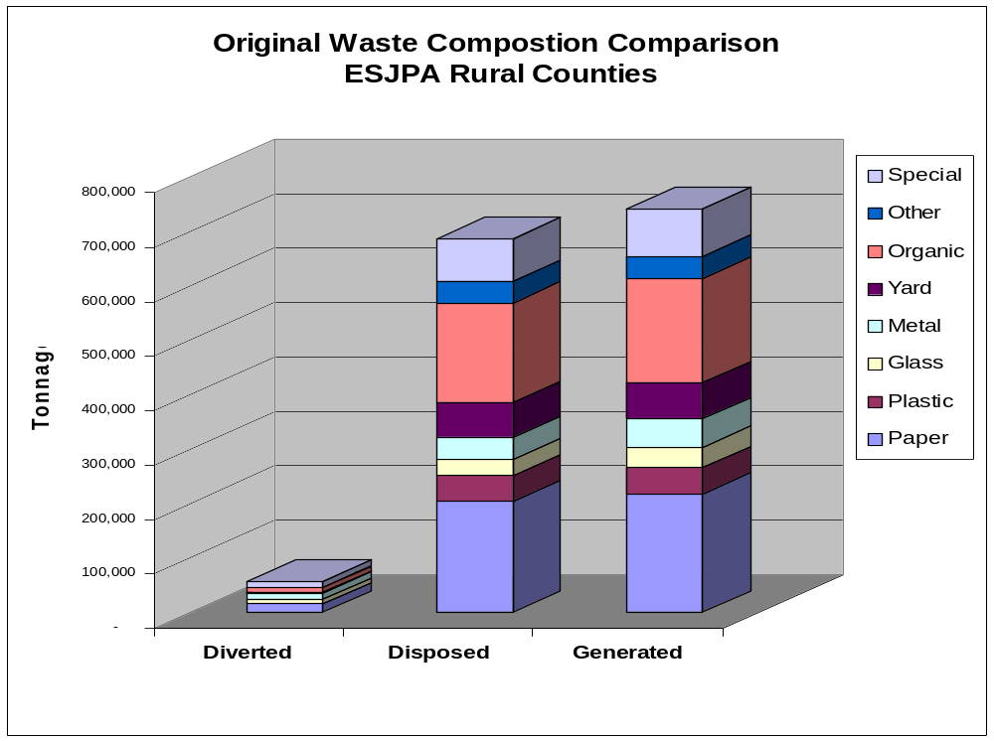This data is a compilation of ESJPA counties original base year (1990-1991) waste composition studies. Appendix A contains a summary of each county’s waste generation data.
Figure 3

Excerpts from the 1990 Waste Generation Data are included in Figure 4 for Calaveras, Mariposa, and Tuolumne Counties. These counties were selected for this example because of their geographic proximity and because they share similar demographic characteristics. Although Calaveras County has considerably more yard waste and organics than the other two counties, the numbers indicate that more diversion of these two materials is possible.
Based upon this data, paper and organics wastes are likely candidates on which to expand the analysis. (Note that, for the purposes of this example, consideration is not given to program developments that have been implemented since the 1990 data was gathered.)

Waste Generation Data for Calaveras, Mariposa, and Tuolumne

 | CALAVERAS |  |  |  | MARIPOSA |  |  |  | TUOLUMNE Not inc Sonora
 | Div | Dis | Gen | % Div | Div | Dis | Gen | % Div | Div | Dis | Gen | % Div
PAPER
OCC/Kraft | 0 | 2754 | 2754 | 0.0% | 530 | 651 | 1181 | 44.9% | 368.9 | 3066.8 | 3435.7 | 10.7%
Newspaper | 0 | 2242 | 2242 | 0.0% | 52 | 460 | 512 | 10.2% | 619.2 | 746.6 | 1365.8 | 45.3%
Mixed Paper | 0 | 2889 | 2889 | 0.0% | 80 | 2096 | 2176 | 3.7% | 0 | 1454.3 | 1454.3 | 0.0%
High Grade | 0 | 327 | 327 | 0.0% | 0 | 70 | 70 | 0.0% | 0 | 251.7 | 251.7 | 0.0%
Magazines | 0 | 0 | 0 | 0.0% | 0 | 0 | 0 | 0.0% | 0 | 0 | 0 | 0.0%
Other | 250 | 3446 | 3696 | 7.2% | 0 | 189 | 189 | 0.0% | 0 | 4061.5 | 4061.5 | 0.0%
TOTAL PAPER | 250 | 11658 | 11908 | 2.1% | 662 | 3466 | 4128 | 16.0% | 988.1 | 9580.9 | 10569 | 9.3%
YARD |  |  | -
Leaves/Grass | 0 | 0 | 0 | 0.0% | 0 | 0 | 0 | 0.0% | 0 | 0 | 0 | 0.0%
Prunings | 0 | 0 | 0 | 0.0% | 0 | 0 | 0 | 0.0% | 0 | 0 | 0 | 0.0%
TOTAL YARD | 0 | 6240 | 6240 | 0.0% | 0 | 322 | 322 | 0.0% | 357.9 | 1985.7 | 2343.6 | 15.3%
ORGANIC
Food | 0 | 3929 | 3929 | 0.0% | 0 | 1782 | 1782 | 0.0% | 0 | 3749.6 | 3749.6 | 0.0%
Wood (untr) | 0 | 4383 | 4383 | 0.0% | 30 | 997 | 1027 | 2.9% | 0 | 6237 | 6237 | 0.0%
Crop res | 0 | 0 | 0 | 0.0% | 0 | 0 | 0 | 0.0% | 0 | 0 | 0 | 0.0%
Tires and Rubber | 0 | 1047 | 1047 | 0.0% | 26 | 47 | 73 | 35.6% | 0 | 841 | 841 | 0.0%
Manure | 0 | 0 | 0 | 0.0% | 1590 | 158 | 1748 | 91.0% | 83 | 0 | 83 | 100.0%
Textiles | 0 | 1648 | 1648 | 0.0% | 3 | 416 | 419 | 0.7% | 0 | 2070.2 | 2070.2 | 0.0%
Other |  | 66 | 66 | 0.0% | 0 | 0 | 0 | 0.0% | 0 | 0 | 0 | 0.0%
TOTAL ORGANIC |  | 11073 | 11073 | 0.0% | 1649 | 3400 | 5049 | 32.7% | 83 | 12897.8 | 12980.8 | 0.6%
TOTAL WASTE STREAM | 1,001 | 41,601 | 42,602 | 2.3% | 2,961 | 11,852 | 14,813 | 20.0% | 2,173 | 55,590 | 57,763 | 3.8%

Div = Diversion Dis = Disposal Gen = Generation
(All numbers are in tons from the 1990 base-year waste generation studies)

Figure 4

Conducting a Voids Analysis

What is a Voids Analysis
A “Voids Analysis” or “Service Voids Analysis” is a process to identify what disposed materials within a region have no recovery programs, and to identify opportunities to expand recovery for other materials being disposed. The Voids Analysis can also assess the existing infrastructure for opportunities to expand existing programs to increase effectiveness, or marketability. The analysis includes prioritizing future programs for recovery of discards.

The Del Norte Humboldt Cooperative Regional Plan identified the goals of a Voids Analysis (Figure 5). The Plan also presented the methodology of conducting Voids Analysis for both a small rural community (Del Norte) and a larger rural community (Humboldt). A smaller community typically has a less complicated solid waste infrastructure – few service providers and facilities. A larger rural community may have a more complicated structure – more service providers, multiple jurisdictions, and greater distances. Regardless of the jurisdiction’s size or complexity, however the same Voids Analysis approach can be conducted.
Goals of a Voids Analysis

The goals of a Recovery Service Voids Analysis are:
1. To systematically select and prioritize target materials and their associated waste reduction, recovery, processing and marketing strategies,
2. To identify recovery service voids: materials for which there is no current mechanism for waste reduction, recovery or marketing, thereby essentially relegating this material to become a waste or litter,
3. To establish a method by which local, regional and state agencies, responsible for implementing waste reduction and recovery programs may agree on priorities and expectations for future recovery programs, and
- To identify recovery service opportunities: materials for which there is some waste reduction and/or recovery mechanism available within the region, though the portion of material being wasted is significant enough to warrant expansion and/or diversification of the recovery programs for that material.

Source: Del Norte Humboldt Cooperative Regional Plan
Figure 5

The Voids Analysis is one tool a jurisdiction can use to start considering how inclusive the cooperative effort will be. Will the cooperative include just the communities within that county or will one or more counties be invited to join? Natural relationships can provide a convenient start. The more participants in the cooperative, the more data needs to be collected and reviewed. Once potential cooperative partners are determined, a Voids Analysis should be conducted on each jurisdiction’s waste stream. The individual Voids Analysis can then be compared to determine whether the selected partners are compatible matches. Finally, it is important to recognize that the Voids Analysis process inherently focuses on materials and their recovery. As such, it is not a recommended tool for evaluating or selecting between alternative waste prevention, product stewardship, public education, information, outreach, market development or advocacy programs. These programs are a vital part of a comprehensive regional recovery effort, and may also be made more effective through regional cooperation. Such programs should be budgeted prior to but prioritized and developed after target materials and recovery programs have been identified and selected.
There are two approaches that a jurisdiction can use to conduct a service Voids Analysis. The key distinction is whether the jurisdiction is attempting to target pre-selected materials for diversion (e.g. wood and green material diversion programs) or if the jurisdiction preparing to conduct a comprehensive review of potential opportunities. Both approaches are valid. The major difference is the order of two steps in the analysis. The pre-selected material approach will take less effort to conduct, but may miss significant opportunities for diversion (e.g., adding food waste and other organics to a composting program). The comprehensive approach takes considerably more effort, but can reveal a number of diversion opportunities. It can also demonstrate to local officials and the CIWMB the potential diversion ability of the jurisdiction and incentives or barriers to implementation of those programs. The two approaches are outlined in the following flowchart (Figure 6).

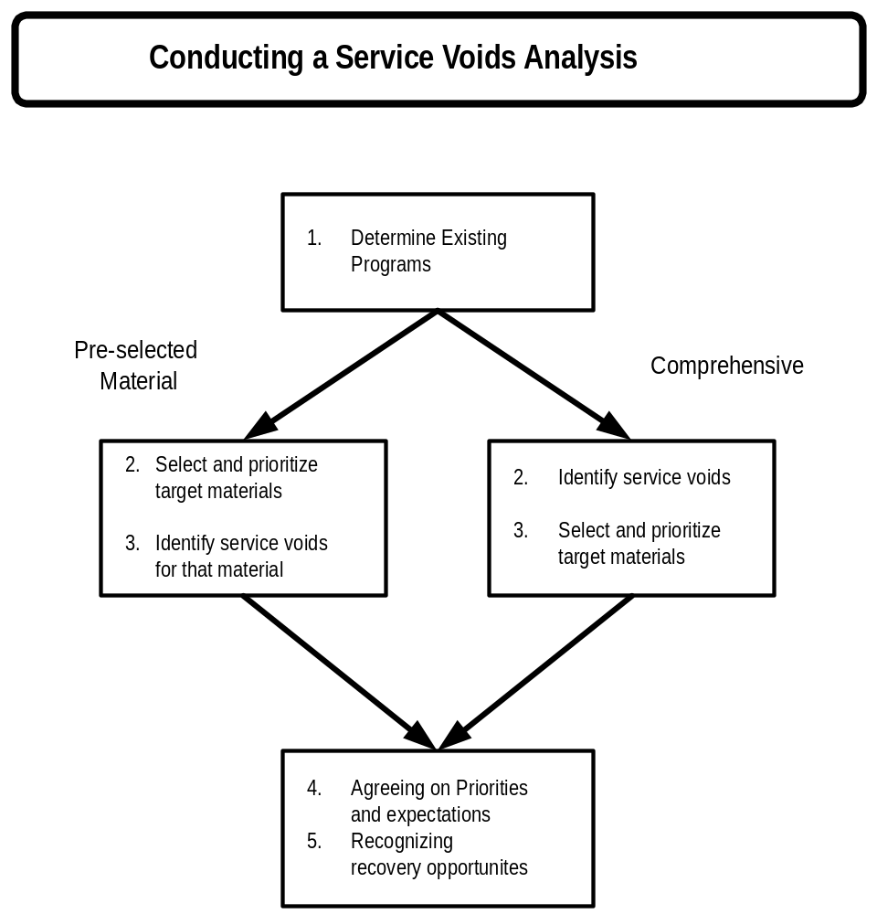
Figure 6

Once a determination has been made to pursue either a comprehensive or pre-selected material approach, the jurisdiction is ready to conduct the Voids Analysis. The approach to conducting a Voids Analysis should mirror the “Goals of a Voids Analysis” as follows:

- Determine existing programs
- Select and prioritize target materials
- Identify service voids
- Agree on priorities and expectations
- Recognize recovery opportunities

Steps to Conducting a Voids Analysis

Determining Existing Programs
Before determining what service voids exist, the jurisdiction must determine the types of existing diversion programs. Knowing the extent of the program is not necessary at this time as long as the program is established. The first place to start would be to contact all jurisdictions involved in the cooperative and obtain their program information. A good starting point is the CIWMB’s Planning Annual Report Information System (PARIS) database. PARIS contains information about the types of programs implemented by jurisdictions regarding waste prevention, diversion programs, and programs to prevent disposal of household hazardous waste. It identifies which programs a jurisdiction selected for its AB 939 program, the status of the program, and if it is not operating, why. Jurisdictions and businesses can use the PARIS notes database located at the website http://www.ciwmb.ca.gov/LGCentral/PARIS/default.htm.

A sample PARIS entry is listed below in Figure 7. A complete entry and reference guide to the codes are included in Appendix B
CIWMB Sample PARIS Notes

Program  Code | E  x  i  s  t | S  l  c  t  d | Pre-  1995  Start  Date | 1995  Status | 1995  Reason | 1996  Status | 1996  Reason | 1997  Status | 1997  Reason | 1998  Status | 1998  Reason | 1999  Status | 1999  Reason | 2000  Status | 2000  Reason
1000-SR-XGC | N | N | 1999 | NA |  | NA |  | NA |  | NA |  | NA |  | AI
Xeriscaping/Grasscycling
1010-SR-BCM | N | Y | 1993 | SO |  | SO |  | SO |  | SO |  | SO |  | SO
Backyard and On-Site Composting/Mulching
1030-SR-PMT | N | Y | NA | NI | 5 | NI | 5 | SI |  | SO |  | SO |  | SO
Procurement
1050-SR-GOV | N | N | 1990 | AO |  | AO |  | AO |  | AO |  | AO |  | AO
Government Source Reduction Programs
2050-RC-SCH | Y | Y | 1988 | D | 8 | DE | 8 | DE | 8 | DE | 8 | DE | 8 | DE | 8
School Recycling Programs
Jurisdiction Selected: Inyo Regional Waste Management Agency
Figure 7

This excerpt from the PARIS database indicates that that Inyo Regional Waste Management Agency has selected and ongoing (SO) Backyard and On-site Composting/Mulching and Procurement Programs. The School Recycling Program was “Dropped in an Earlier Year” (DE) for “Lack of markets necessary to support program”.

Summarizing the PARIS notes involves listing all programs, active and not active, for each jurisdiction. The review for commonalties will occur later. The establishment of an existing program in one jurisdiction can assist in the development of that program in the region. Programs that have been dropped can be reviewed to determine if conditions have changed enough to reconsider the program

Once the PARIS notes on each jurisdiction are summarized, each jurisdiction should verify the current status of the summary and update as necessary.

Selecting and prioritizing target materials
Selecting and prioritizing target materials requires an understanding of the waste stream and the existing infrastructure. This review will result in identifying materials that currently are not being diverted. Once this information is compiled, a jurisdiction can then assess what “voids” exist to provide diversion service to the targeted materials.

Utilizing each jurisdiction’s most recent Waste Characterization Study, a table should be prepared listing the material and any existing or planned diversion program. Each program should be identified separately to allow for a comparison between different collection methods for a material. The data can also be sorted by type of program or facility to determine the effectiveness of a collection method. For example, if drop-off centers are effective for newspaper and metal, additional containers for other materials may be an option to consider. Materials without a recovery program are identified as a “Service Void”. Programs that clearly could be more effective are identified as “Service Opportunities”. For example, if corrugated cardboard has drop-off and subscription collection recovery programs, but comprises only 3% of the disposed waste stream, it would be listed as ‘Service Opportunity,’ because cardboard still comprises a significant fraction of the waste stream. A column for identifying issues, policies and other barriers that may affect diversion may also be added.

The following information is determined for each material present in the waste stream or for a portion of the discarded material stream:

- Amount discarded
- Percentage of total disposal
- Estimated percentage of total generation
- Does the quantity of material reflect the known reality?
- Identify known diversion programs

A sample Voids Analysis of some materials is included in the Figure 8 below. It is important to note that the amount and disposal percentage are listed for the entire amount of material in the waste stream, not for the amount handled by the listed program and facility. The program and facility listing indicates what diversion programs are available for a portion of the waste stream.
Sample Voids Analysis

Material | Amount (tons) | Percent of disposed waste stream | Program | Facility | Issues
Cardboard | 3,436 | 6% | Internal | Supermarket | Litter
Cardboard | 421 | 1% | Service Void | Auto Parts Store
Newsprint | 1,366 | 2% | Drop-off | United Grocery | Space
Newsprint | 40 | 0.1% | Collection | Boy Scouts
Newsprint | 2,750 | 5% | Curbside | Hauler
Mixed Paper | 625 | 1% | Service Void | Hauler
Magazines | 252 | 0.4% | Service Void | Drop-off | Litter
Office Paper | 1,367 | 2% | Drop-off | Landfill | Irregular service
Office Paper | 367 | 1% | Service Void | State Office
Office Paper | 234 | 0.4% | Service Opportunity | Collection

Figure 8

Obtaining all material and program information for a larger region would likely be prohibitive in terms of staff time and other resources. A simpler method would be to obtain the required information on only those materials that have a high priority for diversion.

Determining service voids
Once data have been compiled, the data are then analyzed to determine the priorities for future program development. Assigning priority numbers to each program can assist in selection of target materials. Separate tables can be prepared to summarize by: 1) material type (group paper products together), 2) program type, and 3) percentage of entire waste stream. A review of these tables should indicate what materials are the most likely candidates to target for diversion. The idea is to look for patterns and opportunities. A review of the individual Voids Analysis should be completed along with a comparison between the other cooperative partners. Key criteria to consider include:

- What material types are available in sufficient quantity for diversion?
- What common programs can be seen that might be available?
- What common “Service Voids” and “Service Opportunities” already exist?
- Can any materials, programs, voids, or opportunities be combined?
- Is additional information or market research needed?

Once this assessment is done, the table can be expanded to include additional columns for “Future Program” and “Facility” requirements to conduct the program. The Del Norte Humboldt Regional Plan identified the following Summary of Service Voids and Opportunities (Figure 9):
Summary of Service Voids and Opportunities

Material | Existing Program | Sorted by  % Disposed | Issues | Future Program | Facility
Food Waste | Service Opportunity | 17.85% | Health | Food/Paper | Composting
Other/Composite paper | Service Void | 9.55% |  | Food/Paper | Composting to be developed
Sewage sludge | Service Void | 6.54% | Urgent | Land Application | Land Application
Mattress/Furniture | Service Opportunity | 5.35% | Accumulation | LF Drop-off | LF Container
Fines | Service Opportunity | 4.12% |  | Food/Paper | Composting
Cardboard | Service Opportunity | 3.79% |  | Commercial | TS/MRF
Other plastics | Service Void | 3.79% | Litter + Health | Commercial | TS/MRF
HDPE | Service Void | 3.75% |  | Add to curbside program | TS/MRF
Small appliances | Service Opportunity | 3.70% | Accumulation | Thrift | Thrift Drop-off
Asphalt roofing | Service Void | 3.70% |  | C&D Recovery | Program Devlp
Film plastics | Service Opportunity | 3.16% | Litter
Textiles | Service Opportunity | 3.11% | Accumulation | Thrift | Thrift Drop-off
Treated wood | Service Void | 2.91% |  | C&D Recovery | C&D Resale
(The rest of the summary is located in the Del Norte Humboldt Regional Plan)
Figure 9

Identifying Programs
The final step in the Voids Analysis is to identify and prioritize potential programs. The Voids Analysis in the Del Norte Humboldt Regional Plan reveals the need for a composting operation, for land application of sewage sludge, and for additional collection for mattresses/furniture, cardboard, and plastics.

The following questions can assist in narrowing the potential programs and target materials:

- Is the implementation priority “urgent” (within three years) or “high” (within five years)?
- What barriers exist to establishing viable diversion programs?
- Can the material be readily separated from the discarded materials?
- Can a wider variety of materials be collected by another program (e.g. curbside)?
- Are facilities available, with sufficient capacity, for processing the materials?
- Can existing facilities, equipment, or collection routes serve a larger area?
- Can drop-off sites, satellite facilities, or intermediate processing centers be established to allow points for centralized collection?
- Do other jurisdictions in the region have similar amounts or encounter similar problems?
- Can other jurisdictions contribute to the development of the cooperative recycling?
- Are there geographic, economic, or other advantages to cooperating?
- Can the experiences of one jurisdiction assist others that are geographically distant?
- Can coordination of purchasing, education, and other efforts save costs?

It can be helpful at this point to verify the feasibility or known barriers to establishing a diversion program for the targeted materials. Check in with the solid waste facility operations, recyclers, and generators for this reality check. Keep in mind that old barriers may no longer be valid or can be overcome.

Agreeing on priorities and expectations
Once a list of target materials and programs has been compiled, it is time to verify that the jurisdiction’s priorities and expectations are being addressed. This verification should be repeated throughout the process.

Priority is usually given to developing programs that result in the greatest diversion for the effort. In the Del Norte Humboldt Regional Plan, small appliances and plastics were nearly the same overall percentage disposed, but expanding thrift programs is less difficult then developing a new collection, processing, and marketing infrastructure for plastics. Rather than develop recovery programs for plastics, jurisdictions may want to direct their efforts to support of manufacturer based recovery programs. For example, the Del Norte Solid Waste Management Board recently adopted a policy for extended producer responsibility related to CRTs.

Cooperation between multiple parties in a larger regional area results in a more complex analysis. The Del Norte Humboldt Regional Plan identified a number of additional factors to consider in assessing service voids. These factors are included in Figure 10.

Although a Voids Analysis approach can focus jurisdictions on what materials and programs to target, the market demand may not be available. Markets will either need to be created or another material should be selected. Development of an extended producer responsibility requirement could be one means of increasing marketability of a material. This requirement would require product manufacturers to assist in development of diversion programs for materials produced by their facilities. Additionally, the Voids Analysis could be repeated for a given material at a future date since market conditions are constantly changing.
Regional Voids Analysis Considerations
- Identify ways that a facility, piece of equipment, or collection route may serve a larger region. This can affect the size, scope and economies of scale for recovery programs.
- Identify ways that satellite facilities, whether drop-off collection systems or intermediate processing centers, may be set up throughout a region to better direct feedstock to a central facility
- Elevate the local priority of a target recovery program that could serve a larger region. This can help coordinate the concurrent development of several recovery programs within a region by allowing local jurisdictions to focus their efforts on recovery programs that could serve the larger region.
- Expand and coordinate local purchasing programs which foster development of recovery businesses.
Figure 10

Identifying Potential Market Incentives
Once the Voids Analysis has identified potential target materials, the next step is an analysis of the existing markets and economic development incentives. Without viable markets or other economic incentives for diversion, collection and recovery, programs will either fail, require subsidies, or both. The basic model for assessing market feasibility compares the costs of recycling versus the costs associated with disposal of a material.

This section provides information to determine:

- Calculating economic feasibility
- Identifying existing markets and economic development Incentives
- How to determine general trends in reuse, composting, and recycling
- Summarizing market and incentive information

Calculating Economic Feasibility
The first step in determining economic feasibility is to compare the cost of disposal to the calculated net cost of recycling, including revenue received. In some cases, the net cost of the diversion program will be sufficient to justify implementation. In other scenarios, the economic reality requires the jurisdictions to provide supplemental funds or incentives. A jurisdiction may choose to provide such a subsidy, change local regulatory requirements, or political inclinations may be such that a program is chosen for implementation even if not economically viable. Consideration of these situations should be incorporated into the analysis.

The basic model for determining the economic feasibility of potential recycling opportunities is presented in Recycling Solid Waste: The First Choice for Private and Public Sector Management by Thomas Duston. The formula presented in this document has been slightly modified from the above document and is presented in Figure 11. This formula needs to account for all costs and revenue associated with diversion. Collection costs for diversion may be different than the collection costs for disposal. Collection of diverted materials may require separate vehicles or containers and may be hauled to more distant locations than for commingled disposal of that material in the typical refuse vehicle. Consideration should also be given to costs fluctuations that occur over time (See Figure 12). The question facing local government is how to address these fluctuations. Subsidies or other incentives may be necessary to ensure continued separation of a material and to avoid providing intermittent collection or impacting other diversion programs.
Basic Model - Condition for Feasibility

For recycling of a material to be feasible the following condition needs to be met:

SCR + TCR - PR <PCD + TCD + FD

SCR is Separation Cost of Recycling
TCR is Transport Cost of Recycling
PR is Price for Recycling
PCD is Processing Cost of Disposal
TCD is Transport Cost of Disposal
FD Is Fee for Disposal

Figure 11

The basic formula for determining economic feasibility of diversion asserts that the separation and transportation costs of recycling minus the price obtained by selling the material must be less than the disposal costs including the disposal fee. For example:

If SCR + TCR = $160 and PR = $20, then
SCR + TCR - PR = $150 -$20 = $130, and

If FCD + TCD + FD = $140, then, since$130 < $140, the net cost of recycling Is less than the cost of disposal. If a recycler charged between $130.01 and $139.99, both the recycler and disposer would come out ahead economically.

There are other things to consider than just the calculations on a single recycling material. Recyclers typically do not base their decisions solely on whether the cost of recycling is less the cost of disposal. Three examples of these other considerations are: clustering of recyclable materials, consumer demand, and creating an infrastructure.

A. Clustering of Recyclable materials

Often recyclers cluster a range of materials together in their economic picture. One can calculate the whether recycling costs less than disposal for an individual material, but market prices fluctuate. Most recyclers know the importance of keeping customers coming to their business and may take a material that is very marginal to get another material that has a stronger profit margin. They will look at the overall return of a list of materials to recycle. Increasing tonnages, even marginal ones, spreads the overhead costs over more materials, reducing the overhead costs per ton overtime.

B. Consumer Demand

Different materials are expected to be recycled by the public whether or not they make economic sense. The expectation can be fueled by the past experiences and education of the public. A material example is newspaper which is a traditionally recycled material and has been connected educationally to saving trees, but whose market value can fluctuate dramatically.

Or it can be fueled by advertising by material type, associations that promote the use of a certain packaging material. An example of this would be plastic containers. Huge and comprehensive advertising campaigns by the plastic container industries have convinced the public that plastic is easily recyclable. As a result, the public expects it, even clamors for it, because they have been convinced by these self serving campaigns. So even when the economics don’t come close to equaling out, a recycler may take the material and offset the cost of recycling with another more profitable material to keep the public happy. Or a jurisdiction may end up paying the higher than disposal cost for this material.

C. Creating an infrastructure

Taking certain materials that do not pay for themselves may be part of a longer term plan that could include:

- Ensuring an overall reduction of waste by 50% and fulfilling the state mandate with the long term picture of reducing the cost of waste and landfill costs.
- Creating a source of material feedstock for economic activity, such as recycling based manufacturing.

The steps to analyze the recycling market are as follows:

- Determining existing markets
- Identifying economic development incentives
- Identify general trends in reuse, composting and recycling
- Analysis of incentives
- Assistance to suppliers

Determining Existing Markets
Understanding current market situations is essential for cooperative marketing. Without viable markets, diversion programs will fail or require government subsidy to exist. Markets for many diverted materials fluctuate tremendously over time. Research on markets must consider these fluctuations. One of the best examples is the paper market. It has happened where a material type experiences a negative market values - recyclers must pay for removal rather than receive revenue. As long as the fluctuations even out over time such that the net revenue is acceptable, the diversion program can exist. An example of fluctuating markets for Newspaper (No. 6) is shown in Figure 12. Mixed paper, the lowest grades of paper, has large fluctuations and follow the downward fall of other scrap paper and virgin pulp. When markets are very low, mixed paper has been known to go to negative values where a recycler has had to pay to have it recycled. Recyclers should be wary of these very low grades unless the have a secure market or can ship this oversees to a market. A higher grade of mixed office paper used by some mills, such as Weyerhaueser’s Office Pak, has its own specifications and receives a higher price and more secure market because it is a higher cleaner grade. Clearly, any market review must consider historical trends in pricing.
Historical Prices for Newspaper No.6
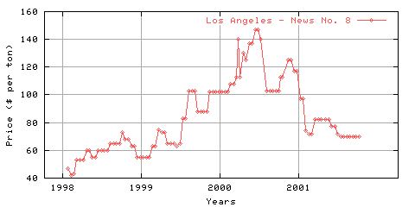
Source: WasteNews
Figure 12

Resources for determining the existing market for diverted materials include:

- Solid waste and recycling services in the region or nearby
- Processors
- Industry trade magazines
- Recycling organizations
- Internet resources, such as RecyclingMarkets.net

Research should determine not only the revenue, but also the costs associated with collection and processing (SCR), and transportation (TCR). Remember, collection costs for diversion will likely be different than the collection costs for disposal. Transportation costs from rural jurisdictions to processors are often the most significant barrier to increasing diversion in the short run. Transportation opportunities and barriers are discussed in the section on “Assessing Rural Transportation Options”.

This would also be the point at which to compile a list of recycling and solid waste marketing opportunities within the region. The Voids Analysis described previously should identify many of these opportunities. Sources for this information include: local solid waste departments, telephone directories, solid waste facilities and their vendors, vendors used by large industries, local thrift and charity organizations, and local salvage operations.

Relating this market information to the feasibility of a recycling program may require additional financial and operational expertise from within the jurisdictions. Most recyclers and solid waste operators can help assess the economic viability of diverting materials and may be willing to assist in this effort.

Identifying Economic Development Incentives
Identifying existing markets and economic development incentives involves a review of what markets exist for recyclables and an assessment of the industrial base within the region. Understanding the existing market situation involves the understanding of how materials are currently diverted and whether the infrastructure exists for expansion of programs to include additional targeted material types. The economic development strategy of a region may reveal possible outlets for diversion of materials. It can also identify possible waste prevention efforts utilized by existing businesses that can be applied to others.

Some resources available for researching economic development include:

- Local Economic Development Plans
- Recycling Market Development Zone (See section on “Taking Advantage of Recycling Market Development Zones” in Part Two)
- Chamber of Commerce
- California Integrated Waste Management Board
- California Department of Conservation, Division of Recycling
- Resources – Federal, state, local, internet

Research should focus on looking for clusters of industries that have similar trends in raw materials utilized and could coordinate `their programs and resources. It is not uncommon in regions with limited commercial or industrial bases that government itself is the largest generator.

Clusters of industries could coordinate their material diversion programs since they typically have existing relationships and common suppliers that can be leveraged to promote diversion efforts. For example, Construction and Demolition companies can be considered as a single industry cluster including: landscapers, equipment operators, concrete and asphalt contractors, masons, tilesetters, general contractors, sheetrock companies, plumbers, electricians, roofing contractors, custom cabinet and countertop shops, finish carpenters, and deconstruction and demolition contractors. Considering all these trades together, they can generate 10% to 40% of a community’s waste stream. A Builders Exchange or similar trade association or even informal communication networks reaching all of these types of businesses may exist in the community. Approaching these trades using these communication networks can reduce outreach costs. Working with opinion leaders within an industry cluster through pilot programs and during development of recovery programs can be one of the most effective mechanisms for program dissemination. This approach can ensure that the local agency designs a recovery program that works for industry, and communicates to other companies within that cluster using their own existing communication network.

Restaurants, cafeterias, grocery store produce departments could work with someone willing to collect from these similar businesses for a composting operation.” Or “All pre-consumer produce scraps could be collected on a route for animal feed at nearby farms.” Or “A distributor of food, office, electronic or other products could collect recyclables from businesses they are distributing do. The materials could then be consolidated at the warehouse

Another source of economic incentives is grants and resources available through the California Integrated Waste Management Board (CIWMB) and the State Department of Conservation’s, Division of Recycling (DOR).

The CIWMB has many resources available for market development and diversion efforts. Each jurisdiction is assigned a local government contact that can assist in obtaining information. The CIWMB’s Market Development site has information and resources encouraging market development and is located at http://www.ciwmb.ca.gov/Markets/. The CIWMB also maintains the Local Government Central Forum located at http://www.ciwmb.ca.gov/LGCentral/. Local Government Central provides resources for jurisdictions to assess their own and other jurisdictions efforts at implementing AB 939 programs. The CIWMB also hosts CalMax, the California Materials Exchange that is a free service to encourage markets for materials that have traditionally been discarded. It also lists materials needed by businesses, industries, and institutions. CalMax is located at http://www.ciwmb.ca.gov/CalMAX/.

Tuolumne County successfully utilized CalMax to divert a significant quantity of traditional diverted materials. See Figure 13 for details.
Tuolumne County CalMax Case Study
The Jamestown Mine office complex in Tuolumne County needed to be removed. The Golden Pond Office Complex consisted of 170 tons of modular office buildings. Upgrading these units was determined to be cost prohibitive, so the Tuolumne County Solid Waste Division listed these complexes on CalMax in late 2000. Some units were relocated within the county for nonhabitable use. After evaluating a number of responses, the County agreed to share in the moving cost of the remaining 11 units to the City of Avenol. The total avoided removal and disposal cost savings of this effort was $38,860.
Figure 13

The DOR has authority over diversion of beverage container recycling. Funds are available to local jurisdictions through the DOR. Currently, DOR grant funds that can only be used for beverage container recycling and litter abatement. Starting with the 1999/2000 cycle, competitive grant awards are no longer limited to nonprofit organizations and government agencies. The city/county payment program is still limited to local government. Information on DOR grant programs can be found at their web site – http://www.consrv.ca.gov/dor/index.htm.
Regional Purchasing Cost Savings Example
The counties of Inyo, Mariposa, Modoc, Trinity, Siskiyou, and the six cities in Siskiyou utilized the services of the ESJPA under their SB 332 payment program. The ESJPA coordinated bulk purchases of recycled-content plastic picnic tables, park benches and other items. Nearly $38,000 was spent on these items. The ESJPA obtained a greater than 30% price reduction from the listed price.
Figure 14

A number of ESJPA rural counties have used these funds to purchase recycling containers, buy recycled content structures such as recycled plastic park benches, establish recycling collection areas, and fund transportation of collected beverage materials to processors. Specific examples of rural funded programs are listed in Figures 13 and 14.

Overall, economic incentive programs can benefit from incorporating recovery and buy-recycled programs. Recovery programs can even demonstrate cost savings. These programs can also be included in low-income housing programs, urban renewal projects, pollution control, and energy conservation programs. The more diverse the opportunities for including diversion programs in economic incentive programs, the greater chance of success.

How to Determine General Trends in Reuse, Composting, and Recycling
A number of resources are available for determining the general trends in reuse, composting, and recycling. This information assists in determining whether a targeted material will be available for diversion in the future or whether there will be an increase in the potential amount of divertible material. This analysis can also be helpful in presenting to the CIWMB in regards to compliance with AB 939 diversion mandates and the ability of the jurisdiction to satisfy those mandates. These resources include:

- Solid waste and recycling operations
- Retail sales data for second-hand merchandise
- Agricultural cooperatives
- Economic development
- Department of Finance
- Realty associations
- Construction contractors
- Magazines on waste management and recycling
- Libraries
- Associations
- Environmental centers

Solid waste and recycling operations are generally readily aware of trends in reuse, composting, and recycling, although some private businesses may not be willing to share some of their more privileged research.

Retail sales data for second-hand merchandise can indicate increases or decreases in reuse. The frequency of garage sales can also assist in gauging trends. This might be an opportunity to bring together reuse organizations with solid waste operations to increase diversion. A simple diversion activity will be to locate a reuse organization’s drop-off trailer at the solid waste facility. This provides the additional incentive of enabling participants to discard materials for recovery and disposal at one location. Convenience for the public is the key to a successful recycling program.

Agricultural cooperatives operate under principles similar to recycling cooperatives. Has the use of compost or mulch increased or decreased in the agricultural community? The “ag” community’s livelihood is totally dependent upon crop yields. A bad load of compost or even the suspicion of problems can dramatically affect usage by agriculture. It only takes one problem somewhere. Remember that agricultural activities have dramatic seasonal variations anyway, so consider these normal fluctuations in the analysis.

Economic development agencies, including the local Chambers of Commerce, monitor and promote business development in a community. Their information can indicate whether business and the associated waste generation is increasing or decreasing. They also assist in business development. Economic development agencies are a resource to local communities in promoting recycling development and dissemination of recycling market incentives (e.g., Recycling Market Development Zones).

The California Department of Finance tracks economic development data for the State and local jurisdictions. This information includes taxable transactions, population trends, and employment statistics. Solid waste operators are also required to submit disposal tonnage to the Board of Equalization on a quarterly basis. The CIWMB compiles these statistics, but be aware that the initial public information on disposal does not include corrected reports from solid waste facilities that were submitted after the initial due date. Jurisdictions should make sure that research into this data includes the basic database information and the corrected reports. The CIWMB also uses the Board of Equalization data for calculation of AB 939 diversion. If a jurisdiction believes that other sources of economic data are more representative, they should formally discuss this with the CIWMB contact.

Realty associations are well aware of the trends in occupancy in the area both on a permanent and seasonal basis. Typically, realty agents are involved with residential and business sector growth.

Construction contractors can provide information on potential new developments or major demolition projects occurring in the region. New developments indicate the need for long-term development of diversion programs. Demolition activities are an opportunity for short-term diversion or dramatic increases in disposal for that period.

Once disposal trend information is compiled, jurisdictions should review the data for similarities and differences. Some information may conflict. One set may indicate a growth in one sector while another indicates dramatic reductions. These apparent inconsistencies should be reconciled or dismissed.

Summarizing Market and Incentive Information
At this point, there should be a good picture of the existing market situation and available economic incentives for either a pre-selected target material or for the overall waste stream. Strong consideration of existing markets and future trends are essential to viable diversion programs

Assessing Rural Transportation Options
Rural jurisdictions are by definition typically located at some distance from metropolitan areas. Thus, transportation of diverted materials will be an even greater expense to cooperative marketing programs than in urban areas. Individual participants in diversion programs will not travel hundreds of miles to the nearest drop-off location.
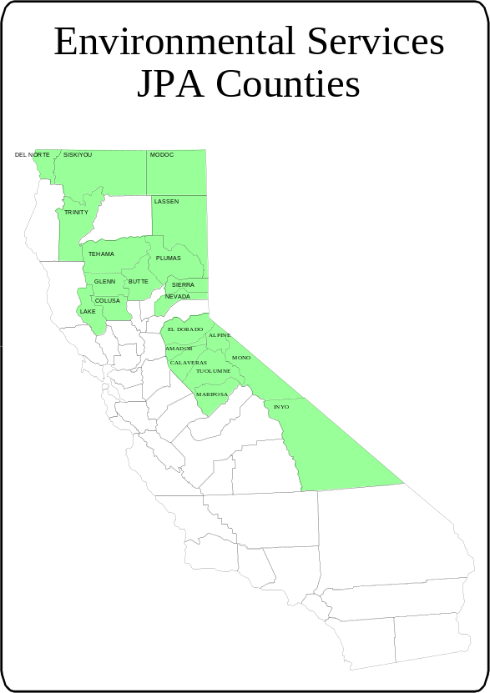
Figure 15

The rural counties represented by the Environmental Services Joint Powers Authority (ESJPA) covers 52,656 square miles (33.8% of California’s 155,973 square miles) (See Figure 15). Despite this large area, these rural counties only have 14% of the streets, roads, and highways in California. Most of these counties have less than half the statewide average of 0.96 miles of roads per square mile area.

The limitations of the existing transportation infrastructure within rural counties are also an incentive for maximum efficiency. Any opportunity to consolidate loads or piggy-back on other commodities can decrease transportation costs.

Emphasis in this analysis will be placed on truck transportation since this is the predominant mode of hauling recyclables.

What is the Current Rural Transportation System
A map of California Highway Truck Map with an ESJPA overlay of county lines is included in Figure 16. This map shows the remoteness of the rural counties to major highways. Although this map indicates highway access to all counties, many of the highways have restrictions vehicle weight and on trailer and overall length. These restrictions can limit the routing of truck hauled materials. This base map and up-to-date truck maps are located at the California Department of Transportation website at http://www.dot.ca.gov/hq/traffops/trksnwim/ motion/truckmap/.
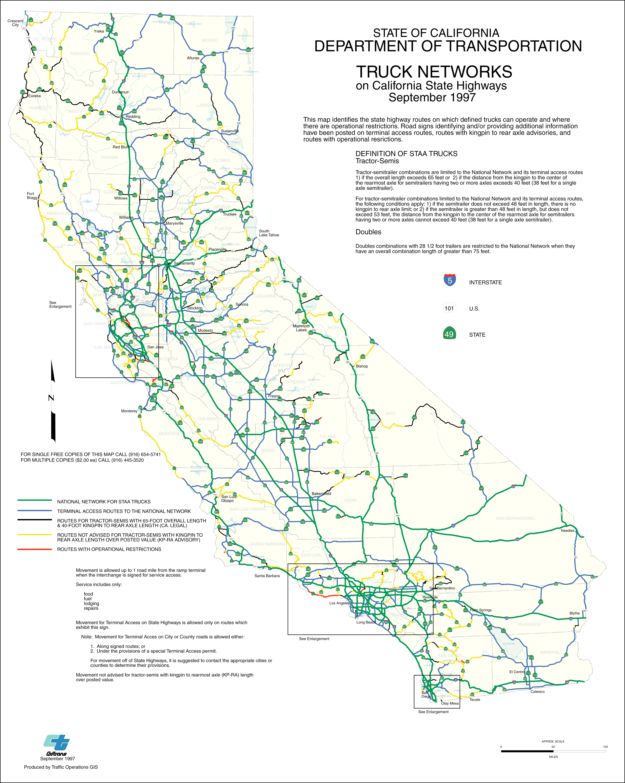
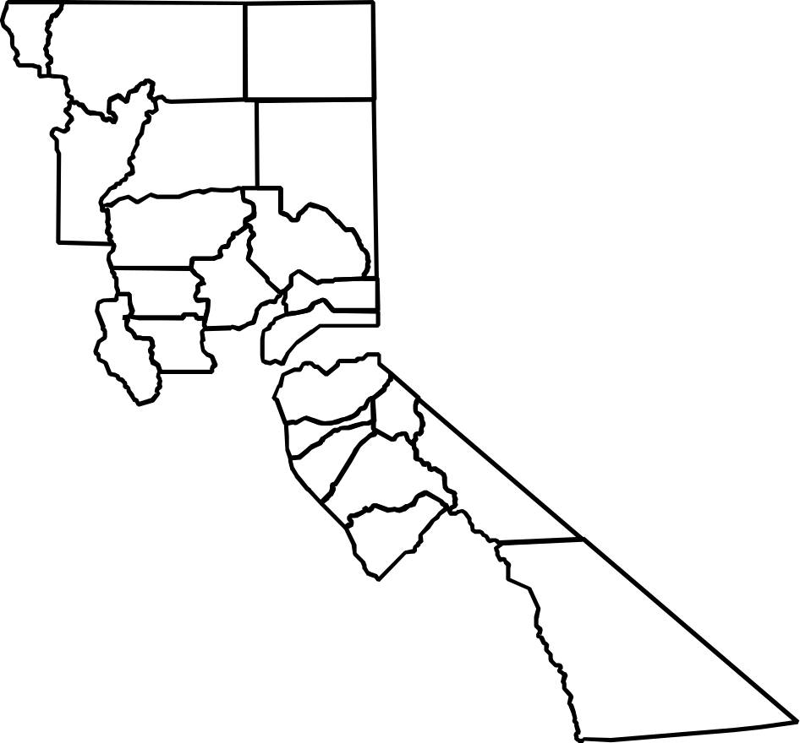
Figure 16
Most rural counties have limited major highway access within the county and between counties. Rail access is also limited in many areas. Access to waterways is also limited. Much of the northern and eastern areas are also impacted by snow and weather conditions resulting in alternate routing and increased hauling distances.

The north central counties have the benefit of Interstate 5 right through the middle of the four counties. The northwest counties are located near coast Highway 1 with cross routes to Interstate 5. Northeastern counties have limited access with most commerce traveling in from Reno or points west. The central foothill counties are located east of Interstate 5 with the less developed Highway 49 running through the counties and parallel to Interstate 5. The east Sierra counties have Highway 395 that connects Los Angeles and Reno. The natural groupings of these rural counties are indicated in Figure 17

ESJPA County Groupings
Northwest/  North central | Northeast | Central Foothill | Eastern Sierra
Del Norte  Trinity  Siskiyou  Tehama  Glenn  Lake  Colusa  Butte | Modoc  Lassen  Plumas  Sierra  Nevada | El Dorado  Amador  Calaveras  Tuolumne  Mariposa | Alpine  Mono  Inyo
Figure 17

These groupings may provide a framework for increased ability of counties to develop cooperative recycling programs. The groupings should not preclude neighboring counties from different groups working together or the groups as a whole sharing certain resources not limited by distance.

Other than the major interstate and state highways mentioned, the remaining roads are two-lane highways or local roads. Some have limited access by large truck and trailer units. The location of diversion programs needs to consider this access. The location of transfer or intermediate processing locations may need to be established near these major transportation corridors.

Regional transportation plans within each county should be consulted for specific information on the current transportation infrastructure as well possible expansions or revisions.

Finding Transportation Opportunities
Despite transportation limitations, jurisdictions can take advantage of existing networks that transport merchandise to rural communities. In fact, many rural areas are experiencing growth. Major shopping chains are making a presence. While these chains may lessen the “rural” feel to these communities, the transportation network is expanding.
Local solid waste collectors, operators and recyclers can provide information on various hauling options. Another option for cooperative transportation would be to share a trip with a neighboring county. It may be advantageous to decrease the amount of material from one county and increase the frequency of existing diverted shipments in order to share the transportation costs. Another way to offset cost may be to utilize other funding sources. The Department of Conservation has a funding program available for collection and transport of California Redemption Beverage containers. Combining a shipment of these containers and other materials could allow for partial subsidy of the costs. Another approach would be to take advantage of backhauls.
The large grocery store chains have figured out that when they deliver their products in vans, they can put bales of OCC (cardboard) in the van truck for a back haul to the warehouse. There they ship out full truck loads of OCC directly to the market maximizing the price they receive for the OCC and avoiding transportation cost to the warehouse by using the returning distribution truck.
There is a lot for the rural area to learn from this efficiency of the larger stores. If a rural region was to look at all the distribution vehicles, then ask the question, how could this network be used to make recycling more efficient, or possible in remote areas. A creative collection program could be designed using these distributing vehicles to pick up recyclables from their clients and backhaul materials to a centralized warehouse. Consolidation of materials could take place there. Debris boxes could be used to ship the material collected to a local recycling center.

Review of Back-haul Options.
Backhauling is the utilization of the return trip of a truck that has dropped off its load. Backhauls may be limited in rural areas, but the increase in growth will provide more opportunities in the future.
The Del Norte Humboldt Regional Plan identified several internet truck backhaul brokerage services. Web search engines can be used to identify sites. Some of these sites include:

- www.backhaul.net,
- www.loads.com
- www.americasloadsonline.com
- www.tloads.com, and
- www.getloaded.com

These brokerages list the weights, sizes, and destinations of loads needing delivery. Jurisdictions can use these brokerages to list shipments of diverted materials. Since diverted materials can be containerized and stored for periods of time, backhauling may provide an opportunity to reduce transportation costs.

Review Humboldt/Del Norte Transportation Cost Model
The Del Norte Humboldt Regional Plan identified a process for analyzing transportation costs. This process is identified in Figure 18. This analysis provides a process for determining transportation costs for markets within and outside of the cooperative region.
Process for Analyzing Transportation Costs
1. Starting with market opportunities outside of the region:
a. Identify a potential market and destination for a material or product containing the material as recycled content (or identify a destination and research to see if there is a potential market in that location)
b. Get estimates of price per unit (e.g. price per ton) and volume considerations (minimum amount accepted, price variations as to quantity and quality).
c. List transportation options (modes, transloadings, "milk runs", backhaul possibilities etc.) relevant to the particular destination.
d. Calculate implied Separation Cost of Recycling (see Task 2) and determine if there is a transportation cost and separation cost combination that meets the economic feasibility condition.
e. Double check to see if changes to separation costs or fees for recycling would make a transportation/separation cost option feasible.

2. Starting with market opportunities for sale or disposal of the particular material within the region.:
- Identify market opportunities either for collection for transport outside of the region or
- For use as recycled content for a product sold either within or outside of the region.
- Examine the transportation options as in 1b - 1e above.

Figure 18

Part Two: Developing Activities, Programs, Resources and Options
Once the analysis of the current recycling infrastructure is complete, the participating jurisdictions should target selected materials for the development of diversion activities and programs.

How to Sponsor an Innovators Forum
This section provides suggestions on conducting an Innovators Forum. The components of an Innovators Forum are presented along with examples of successful Forums. Possible Forum topics for rural counties are also discussed. Information on conducting an Innovators Forum was based upon the efforts of Maureen Hart.

Topics in this section include:

- What is an Innovators Forum?
- How to plan and organize a successful Forum?
- Selecting a material for the Forum
- Determining who to invite
- Selecting a meeting place
- Preparing Discussion questions
- What happens at the Forum
- Setting the agenda
- Evaluation and follow-up
- How to turn the ideas into a viable business?
- Examples of successful Forums
- Suggested Forum topics for rural counties

What is an Innovators Forum?

Goal
The overall goal of the Innovators Forum is to encourage the reduction of wastes going to the landfill through the development of new businesses concepts or outlets for diverted materials. The Forum should facilitate the creativity and visioning of a group of Innovators and experimenters to generate the road map and strategy plan for reducing wastes generation or creating a potential reuse or recycled destiny.

Objectives
The Forum is a facilitated work session examining process and potentials of materials for reduction, reuse, or recycling. An Innovators Forum can achieve some or most of these objectives:
- Generate clear definable and detailed strategies for the reduction, reuse, and/or recycling for materials that have unstable or low value markets.
- Examine the collection and processing efficiencies related to handling these materials.
- Facilitate the commitment of an organization, business or individual in the projected solution to the scrap material.
- Reduce the generation of waste through different approaches to the process or manufacturing of a product.
- Replace a material with one that is reusable or recyclable.
- Brainstorm ideas that have not been thought of before and could lead to small or cottage industries, or a new product developed within a business, or in the synergy of a number of discarded materials pooled together to create the feedstock for a new product.

Types of Innovators Forums
Innovators Forums can be developed in a number of formats including those types identified in Figure 19:

Types of Innovators Forums

Type of Forum | Desired results | Participants
Geographic | Program Development , Networking | All sectors within region
Generator | Waste prevention, On-site management, Collections development | Similar generators of target materials, gov’t, collectors, innovators in on-site management
Investor | Funding development for expansion | Venture capital firms, financial institutions, companies ready to expand
Reuse & Repair | Program development,  Collections development,  Facility development | Reuse and repair operators, collections companies, facility operators, reuse and repair innovators
Material Demand | Processing and transport cooperation, collections and separation development | Processors, Companies with substitution potential, government, haulers
New Product Development | Examination of materials, new product ideas, resources, next steps | Innovators, Inventors, Artists, Engineers, Students in Design, creative thinkers
Outreach/ Education | Develop educational opportunities | Schools, educational centers, offices, agency public relations staff, CIWMB
Figure 19

Examples of successful Forums
Information on how to conduct an Innovators Forum is included in Appendix C. The Del Norte Humboldt Regional Plan conducted a series of successful Forums including:

Forum Topic Forum Type
- Construction, Deconstruction, and Value-Added Forum Generator
- Textile Innovators Forum New Product
- Del Norte Household Reuse Innovators Forum Reuse & Repair
- Humboldt Household and Electronics Reuse Innovators Forum Material Demand

The “Construction, Deconstruction, and Value-Added Forum” was held on April 19, 2000. The focus was on reducing construction waste. Topics included development of a transfer/collection center, building and demolition permits, deconstruction techniques, and new business ideas. The result of this effort was that the Arcata Community Recycling Center (ACRC) added used building supplies to the list of materials accepted for recovery, grant applications are underway, and a company that makes furniture was connected with the ACRC.

The “Textile Innovators Forum” was held on October 11, 2000 with over 25 attendees. Emphasis was to examine garment manufacturing waste and discarded textiles. The Forum opened with a presentation on the Institutional Textile Reuse and Recycling Project. The afternoon session covered brainstorming ideas for new products from scrap textiles. One problem identified was that the normal efficiency of textile production is decreased since individual handling is required. The Forum resulted in production of pillow products from scraps. Scrap textiles are available through the ACRC. Development of art kits and extruded wall board production are also under development. The regional RMDZ administrator assisted with the development of these concepts and utilization of the RecycleStore.

The “Del Norte Household Reuse Innovators Forum” focused on creative reuse of household products and expansion of reuse and repair centers. Industrial zoning restrictions were identified. The Del Norte Solid Waste Management Authority incorporated the results of the Forum into a successful application for a CIWMB Reuse Assistance Grant to design and permit the Del Norte Reuse Center. Work is also under way to identify and support the existing network of skilled repair people.

The “Humboldt Household and Electronics Reuse Innovators Forum” focused on reuse, repair, and dismantling of consumer products. Updates to the local reuse referral booklet were obtained. The low cost of many electronics makes repair not an economically viable effort. Dismantling for parts was considered as more viable. A local computer repair and dismantling project received funding as a result of this Forum. Public education on buying repairable items, maintenance and longevity was discussed.

Suggested Forum topics for rural counties
Innovator Forums can provide rural areas with local market development opportunities. Local markets can overcome the transportation barriers of hauling diverted materials.

Some suggested topics for rural county Forums include:

- Construction and demolition,
- Reuse and repair,
- Carpets,
- Electronics, and
- Wallboard.

Each of the materials identified in the above list is typically collected at rural solid waste facilities.

Using The RecycleStore as a Marketing Tool
The purpose of this section is to promote the use of the CIWMB RecycleStore website as a marketing tool within the Rural Cooperative Recycling concept.

What is the Recycle Store?
The RecycleStore presents innovative recycled-content products and provides direct access to the manufacturers for both individual consumers and wholesalers. This site provides an opportunity to increase the purchase of recycled-content products. Jurisdictions wanting to promote local recycled content products can use the RecycleStore. Samples of RecycleStore products and fact sheets are included in Appendix D. The site is located at http://www.ciwmb.ca.gov/RecycleStore. The RecycleStore can also assist in fulfilling local government recycled product procurement mandates.

There are over one hundred products listed at the RecycleStore in one of the following categories:

- Building Materials
- Children
- Furniture
- Gardening
- Gifts
- Household
- Industrial
- Jewelry
- Miscellaneous
- Office
- Pets
- Promotional
- Sports
- Textiles

Some items are functional (heavy-duty rubber floor mats made from recycled tires). Others are playful (Ornamental Tin Man, a Tin Man Craft Kit). Some manufacturers can personalize their products to specifications. All products in the RecycleStore are manufactured by companies located in California's Recycling Market Development Zones (See the section on “Taking Advantage of Recycling Market Development Zones (RMDZ)”.

Utilizing e-commerce has special attraction for rural manufacturers since it allows a greater marketing audience than local outlets and listing is free. It also reduces the overhead associated with establishing a retail outlet.

Finding Products to Include in the RecycleStore
Through the efforts of the Del Norte Humboldt Regional Plan, thirty products were listed in the RecycleStore. A contractor for the Del Norte Humboldt Regional Plan wrote the script to advertise the products and took digital pictures of the merchandise. A list of these products is included in Figure 20.

The Del Norte Humboldt Regional Plan team found the following information useful when soliciting manufacturers for the RecycleStore.

- Contact local recycling staff for referrals
RecycleStore Products Promoted by the Del Norte Humboldt Regional Plan
- Baja BBQ
- Ecoating Paint
- Remanufactured Mattress/Box
- Glass Hearts
- Tableware
- Foxfarm Fertilizers
- Ocean Forest Organic Potting Soil
- Cloth Pot Holder
- Cloth Tote Bags
- Coffee Table with a View
- Jelly Jar Window Cabinet
- Stand Alone Compact Disk Rack
- Vintage Beaded Redwood Door Cabinet
- Vintage Window Small Buffet
- Bow Arm Chair
- Copper Top Table
- Dining Table
- Douglas Fir Stool
- End Table
- End Table, 45 degree turn legs
- Folding Barrel Save Chair
- Frank Lloyd Wright Bench
- Large Coffee Table
- Oak Dining Chair
- Prairie Love Seat
- Prairie Settle Loveseat
- Prairie Style Chair
- Spindle Arm Morris Chair
- Ottoman
- White Oak Love Seat
Figure 20

- Utilize Innovator Forums for promotion
- Inform recycling centers
- Contact local stores that feature local artists and artisans
- Announcements at meetings

Jurisdictions can also display RecycleStore merchandise at government offices and regional events.

Once a contact is made, manufacturers will need information regarding the RecycleStore. Any assistance that jurisdictions can provide will assist since many small manufacturers or artists have limited time and resources to market their materials.

How to Use the RecycleStore
In order to get products listed on the RecycleStore, manufacturers need to contact the CIWMB at (916) 341-6523 or the local Recycling Market Development Zone Administrator. Recycled content requirements vary based on the type of recycled material used. The guidelines for marketing on the RecycleStore are simple:

- Four images are allowed per product.
- Show only one product per image.
- The image for the catalog page should display only the product. Use other items sparingly and only if they demonstrate how the product can be used.
- The product image should be taken close-up and fill the image.
- Take the photograph at the angle that best displays the features of your product.
- The three remaining images can be used to demonstrate how your product is used or other features you wish to highlight.
- Images should be bright and clear.
- Use simple backgrounds that will add to, not distract from, your photograph.
- Images should be in jpg format.
- Images displayed on the RecycleStore are formatted to a maximum size of 250 pixels by 250 pixels.

The CIWMB does require manufacturers advertising on the RecycleStore to sign a contract.

Taking Advantage of Recycling Market Development Zones (RMDZ)

What is the RMDZ Program?
Recycling Market Development Zones (RMDZ) are a partnership between local governments and the CIWMB with the objective to stimulate the use of secondary materials as feedstock for recycling manufacturing businesses. Low interest loans are provided to recycling-based businesses located in RMDZs. Each Zone has assigned a Zone Administrator to assist in promoting economic development opportunities in the area. The Administrator works with the CIWMB’s Board's Recycling Business Assistance Referral Team (R-Team). Assistance may include financial assistance, product marketing, and permitting assistance. Local incentives vary by jurisdiction. Some typical incentives include: relaxed building codes and zoning laws, streamlined local permit processes, reduced taxes and licensing, and increased and consistent secondary material feedstock supply.

A total of 40 RMDZs are currently established in California. Information on RMDZs is included in Appendix E. A number of RMDZs are in rural areas including the following ESJPA counties:

- Siskiyou County
- Northeastern California (Modoc/Lassen/Plumas Counties)
- Chico/Northern Butte County and the City of Oroville
- Glenn County
- Sonoma/Mendocino/Lake Counties
- Mother Lode (Tuolumne/Calaveras Counties)
- North Coast Recycling Market Development Zone (proposed Del Norte/Humboldt Counties)

The RMDZ loan program has funded 60 loans worth $25.5 million dollars since its inception in April 1993. Nearly 700 jobs have been created and 1.6 million tons per year of secondary materials have been recycled into new products. Typical uses of the money include purchase of equipment, site improvements, and working capital. Information on the RMDZ program is located at the CIWMB website at http://www.ciwmb.ca.gov/RMDZ/

Some examples of RMDZ loans listed on the CIWMB website include:

September 6, 2001: Sandler Brothers, a Los Angeles County manufacturer, will increase its efforts to recycle and keep fabric waste out of local landfills with help from an RMDZ low-cost business loan. The company takes discarded postconsumer and postindustrial cloth materials and manufactures more than 250 different types of new wiping rags that are sold to janitorial supply companies, the military, paint stores, printing companies, and furniture manufacturers. The recycling loan will be applied toward the purchase of commercial property to consolidate two currently leased facilities

September 11, 2000: Whit McLeod Furniture in Arcata is a locally recognized furniture manufacturer. Whit has been conserving, reusing and recycling for more than 20 years. The company will use its $195,000 RMDZ loan to purchase property, make site improvements, and purchase machinery. The project was anticipated to divert an additional 100 tons of wood from landfills each year

Identifying Opportunities for Expanding Rural RMDzs.
To a large extent, the RMDZ programs have been an underutilized economic tool in rural areas. As Rural Cooperative Recycling programs occur, the RMDZ can be a tool to assist in that effort. Given the unique nature of rural jurisdictions, the RMDZ coordinators could network with other rural RMDZ coordinators or one coordinator could serve as a lead coordinator for multiple counties. This network could facilitate sharing of experiences to successful RMDZ applications. Rural jurisdictions should consider all options to streamline the RMDZ process.
Other benefits can result from Cooperative RMDZs. The process to expand the Humboldt RMDZ to include Del Norte facilitated a number of other cooperative efforts. The North Coast Recycling Market Development Zone required joint efforts to compile waste generation and market incentive information. The administrative structure to establish the RMDZ also seemed to be the most effective arrangement for future cooperative diversion program development.

Sharing Resources With Your Neighbors
The most complex and critical component of Rural Cooperative Recycling programs is the assessment of what resources can be shared between jurisdictions. For purposes of this assessment, resources include physical equipment, technology, information, and any other means of cooperation.

The ESJPA itself is an example of a shared resource since it provides staffing and technical expertise to member counties.
Del Norte Humboldt Regional Plan
Methodology to Determine Shared Resources
- Compile Background Material
- Review and Organize Information
- Develop a system for assessing “Co-opportunities”
- Facilitate Assessment of co-opportunities
- Identify Short-term Opportunities
- Identify Long-term Opportunities
- Continue to monitor and evaluate achievement

Figure 21

The Del Norte Humboldt Regional Plan identified the process in Figure 21 in order to assess opportunities for sharing resources. This is an ongoing process. New opportunities for sharing resources will continue to appear.

Compile Background Material
This step involves collecting existing and potential resources that can be shared. The Del Norte Humboldt Regional Plan developed a “Criteria and Scoring for Evaluating Waste Reduction Programs for Coordination and Consolidation” to assist in compiling and evaluating this information. A copy of this evaluation is included in Appendix F. Resources identified at this step can include programs and equipment currently in use in one jurisdiction but that might have potential to be shared with other jurisdictions.

Review and Organize Information
Each jurisdiction should complete an evaluation for their own community and then the results can be reviewed and consolidated. Potential co-opportunities are grouped under the headings of:

- Technology
- Equipment
- Facilities
- Programs
- Policies
- Information
- Personnel

This data compilation can then be reviewed and sorted into categories of waste reduction, salvage, recycling, and composting.

Develop a system for assessing “Co-opportunities”
Assessing co-opportunities is the next step. Co-opportunities are identified as to whether the program is existing or future, the type of cooperation required, and what agreement is required. The California Integrated Waste Management Board PARIS program codes should be used in development of the system.

Facilitate Assessment of co-opportunities
Once this information is compiled, the involved jurisdictions need to evaluate the feasibility of the potential co-opportunities. Co-opportunities can be ranked as to high, medium, and low priority and feasibility. Once programs are prioritized and selected, implementation schedules and responsibilities should be assigned.

Identify Short-term Opportunities
Short-term opportunities should be identified. These typically consist of less complicated, low overhead, or regional public information programs. Existing businesses or even start-up operations can be used. Del Norte identified a short-term opportunity by using the Eureka’s existing St. Vincent De Paul metal appliance salvage program to direct top loading wash tubs into a business manufacturing recycled-content “Baja Barbecues”’ Other materials considered for short-term opportunities included regional coordination of expanded recovery of mattresses and appliances.

Identify LonG-term Opportunities
Long-term opportunities (four to five years) can be started concurrently with short-term ones. The Del Norte Humboldt Regional Plan identified the development of a “Construction and Demolition Drop-off and Reuse Center” as a long-term opportunity. These opportunities will typically need more formalized agreements and funding.

Reaching an Agreement
Many factors can impact obtaining an agreement. The more formal the agreement, the more complex obtaining that agreement will become.

One of the keys to developing a successful agreement is to ensure that the needs of all parties are addressed. Each party’s needs and responsibilities should be clearly defined to minimize future misunderstandings.

Open communication is essential. Decisionmakers should fully understand the advantages, cost impacts, risks, and potential problem areas. This will require sufficient research into all of these factors. It can be helpful to meet with key stakeholders early in the process to obtain their feedback. It also can help to determine if the involved parties have any other mutual agreements in place. If so, discussing the success and barriers of those agreements with involved parties may assist in obtaining approval.

Flexibility is critical. Rarely will the final concept not be changed from the original idea. Modifications will be requested throughout the review process. The most important consideration is fully understanding which aspects of the proposed agreement are essential and must remain fairly intact and which points can be modified. Changes to the core concepts make require reconsideration or restructuring or the entire agreement.

A successful agreement is possible with sufficient planning and support

Continue to monitor and evaluate achievement
Monitoring and evaluation of shared resources is an ongoing activity. Market fluctuations and changing regulatory requirements can quickly impact programs. Jurisdictions involved in cooperative recycling programs need to continuously assess their own programs and meet to share experiences.

How to Promote Government Purchasing for Waste Reduction
Local governments may wish to increase their buy-reusable and buy-recycled procurement efforts for a variety of reasons. In addition, the CIWMB requires buy-recycled procurement policy of all local jurisdictions applying for grants and loans and is now requiring demonstration of actual procurements rather than just adoption of a policy. Procurement by jurisdictions can also facilitate increased buy-recycled procurement by local businesses. Most ESJPA counties have adopted some type of “Buy-Recycled” Procurement Policies

Determining Your Potential for Recycled-content Procurement
Coordinating Government Procurement
- Review existing conditions
- Coordinate meetings with local procurement agents
- Adopt local ordinances and policies
- Identify and compile a resources catalogue
- Present options to local government purchasing agents
- Prepare a model procurement recommendation for local government agencies
- Identify locally-produced recycled-content products for increased use by county agencies

Figure 22
The Del Norte Humboldt Regional Plan identified the seven steps in Figure 22 regarding development of local government buy-recycled procurement. These steps are discussed below as they relate to other rural entities.

Review existing conditions
If a procurement policy has not been adopted, jurisdictions may still have conducted procurement programs or recycled-content purchases. Samples of procurement policies are included in Appendix G. Local procurement agents should be identified.

Coordinate meetings with local procurement agents
Once a policy is established, jurisdictions should try to quantify existing procurement programs. Likely sources to assess procurement are local purchasing departments and public works agencies. Is purchasing centralized or are departments self-sufficient?

Information to collect on existing procurement programs is:
- Type of material purchased
- Price comparisons between recycled-content products and virgin products
- Supplier and availability
- Quantity price breaks
- Testimonials on successful use of recycled-content products
- Barriers to implementation including historical difficulties

This compilation will assist with later steps to promote procurement especially with local government approval.

Adopt local ordinances and policies
The adoption of a buy-recycled policy can be controversial. Jurisdiction staff should compile the above information and discuss approaches with other jurisdictions.

One fear of adopting a buy-recycled procurement policy is that purchasing costs will increase. The cost of many recycled-content products is becoming comparable or equal to virgin products. Historical research on the cost of buy-recycled products should be updated or verified to insure proper assessment.

Jurisdictions may also wish to consider subsidizing the purchase of recycled content products. Inyo County purchased park benches constructed out of recycled plastic with a Department of Conservation grant. This decreased the cost of purchasing and demonstrated successful buy-recycled procurement.

Another barrier to address is an agency’s resistance to change. Many procurement agents are reluctant to switch to a different product, recycled-content or not, since a failure of the product will reflect negatively on the agent. Pilot projects can be the first step to overcoming this barrier.

Sample procurement policies are included in Appendix G. Prior to adopting new policies, individual jurisdictions may wish to consult with CIWMB staff and be sure that the policy meets CIWMB requirements for grant funding.

Identify and compile a resources catalogue
Each jurisdiction can compile a resources catalog that identifies suppliers of recycled-content products specific to the needs of that jurisdiction. This custom resources catalog provides local purchasing agents with an easy reference for purchasing recycled content products. Several existing catalogs exist that can be used as a basis for this local guide. This listing should include products commonly utilized by the jurisdiction including office paper, office supplies, furniture, construction materials, traffic supplies, and reprocessed oil. These listing should also include quantity pricing. These references include the “Catalog of Web Resources and Networks”, a compilation including internet links from the CIWMB, Solana Recyclers, Californians Against Waste, National Recycling Coalition, and Washington State’s Model Buy-Recycled Site.

Some of these websites include:

- CIWMB, Recycled-Content Product Database
http://www.ciwmb.ca.gov/RCP/
- CIWMB, Recycled-Content Construction Product Manufacturers Database
http://www.ciwmb.ca.gov/ConDemo/Products
- Solana Recyclers (See Figure 23)
http://www.beresourceful.org/
- RecycleStore
http://www.recyclestore.com

Present options to local government purchasing agents
Solana Recyclers
Solana Recyclers developed the Recycled Products Purchasing Cooperative, (RPPC) with the goal to increase the use of recycled paper by both the public and private sectors. One of the main products available through Solana Recyclers is a 30 percent postconsumer recycled paper that is elemental chlorine free. This project was partially funded by the U.S. EPA Region IX and the paper is tested and recommended by the U.S. Government Printing. There is no cost to be a member of the cooperative. Solana Recyclers guarantees their discount-pricing schedule to all customers.

Tyson Miller, Program Manager
Solana Recyclers
137 N. El Camino Real
Encinitas, CA 92024

(760) 436-7986
(760) 436-8263 fax
E-mail: solana@adnc.com
Figure 23
Once a list of resources has been compiled, the information including pricing should be distributed to local purchasing agents. Any recommendations and suggestions should be discussed. The intent is to ensure that the agent is aware of buy-recycled procurement opportunities. Agents can be encouraged to coordinate quantity purchased within the various agencies and the other jurisdictions in a rural cooperative recycling region. Some services like the Solana Recyclers’ office paper purchasing programs are based upon the total quantity of products purchased regardless of location. The more material ordered, the greater the discount.

Prepare a model procurement recommendation for local government agencies
The recommendations for buy-recycled procurement should be compiled into a procurement program that is distributed to the local agencies.

Identify locally-produced recycled-content products for increased use by county agencies
Locally-produced recycled-content products should be included and highlighted in the local procurement guide.

How to Develop Regional Agreements
Regional agreements are the foundation for a rural cooperative recycling program. The primary benefit of a regional agreement is to consolidate efforts thereby increasing marketing potential, streamlining program development, and cost-effectiveness.

A number of the counties, including some cities, have formed regional agencies for purposes of consolidating efforts under AB 939 and are allowed to measure diversion jointly. These regional agencies can serve as a starting point for even more inclusive cooperative regional recycling efforts. The current regional agencies approved by the CIWMB include:

- Amador County Integrated Solid Waste Management Agency (ESJPA Member)
(Amador City, Amador-Unincorporated, Ione, Jackson, Plymouth, Sutter Creek)
- Butte Regional Waste Management Authority (ESJPA Member)
(Butte-Unincorporated, Paradise, Biggs)
- Colusa County Regional Agency (ESJPA Member)
(Colusa, Colusa-Unincorporated, Williams)
- Consolidated Waste Management Authority (Tulare County)
(Dinuba, Lindsay, Porterville, Tulare, Visalia)
- Del Norte Solid Waste Management Authority (ESJPA Member)
(Crescent City, Del Norte-Unincorporated)
- Glenn County Waste Management Regional Agency (ESJPA Member)
(Glenn-Unincorporated, Orland, Willows)
- Inyo Regional Waste Management Agency (ESJPA Member)
(Bishop, Inyo-Unincorporated)
- Kings Waste and Recycling Authority
(Corcoran, Hanford, Kings-Unincorporated, Lemoore)
- Lassen Regional Solid Waste Management Authority (ESJPA Member)
(Lassen-Unincorporated, Susanville)
- Marin County Hazardous and Solid Waste Management Authority
(Belvedere, Corte Madera, Fairfax, Larkspur, Marin-Unincorporated, Mill Valley, Novato, Ross, San Anselmo, San Rafael, Sausalito, Tiburon)
- Merced County Solid Waste Regional Agency
(Atwater, Dos Palos, Gustine, Livingston, Los Banos, Merced, Merced-Unincorporated)
- Sacramento County/City of Citrus Heights Regional Agency
(Citrus Heights, Sacramento-Unincorporated)
- San Benito County Integrated Waste Management Regional Agency
(Hollister, San Benito-Unincorporated, San Juan Bautista )
- San Luis Obispo County Integrated Waste Management Authority
(Arroyo Grande, Atascadero, Grover Beach, Morro Bay, Pismo Beach, San Luis Obispo, San Luis Obispo-Unincorporated)
- Shasta County Waste Management Agency
(Anderson, Shasta Lake, Shasta-Unincorporated)
- Sierra County Regional Agency (ESJPA Member)
(Loyalton, Sierra-Unincorporated)
- Siskiyou County Integrated Solid Waste Management Regional Agency (ESJPA Member)
(Dorris, Dunsmuir, Etna, Fort Jones, Montague, Mount Shasta, Siskiyou-Unincorporated, Tulelake, Weed, Yreka)
- Sonoma County Waste Management Agency
(Cloverdale, Cotati, Healdsburg, Petaluma, Rohnert Park, Santa Rosa, Sebastopol, Sonoma, Sonoma-Unincorporated, Windsor)
- Tehama County Sanitary Landfill Regional Agency (ESJPA Member)
(Corning, Red Bluff, Tehama, Tehama-Unincorporated)
- Upper Valley Waste Management Agency
(Calistoga, Napa-Unincorporated (portions), St. Helena, Yountville)
- West Contra Costa Integrated Waste Management Authority
(El Cerrito, Hercules, Pinole, Richmond, San Pablo)
- Yuba/Sutter Regional Waste Management Authority
(Gridley, Live Oak, Marysville, Sutter-Unincorporated, Wheatland, Yuba City, Yuba-Unincorporated)

The ESJPA itself is an example of a regional agreement. ESJPA member counties are provided with information on regulatory and legislative developments impacting recycling and management of solid wastes. As necessary, the ESJPA works with the relevant regulatory agencies to provide input into proposed requirements and policies. In addition to providing a regulatory and legislative resource for member counties, the ESJPA provides grant services for member counties. These services include: staff assistance, bulk purchasing, permitting and regulatory approvals, and grant administration. In many cases, participating counties would be unable to provide their own resources to provide these services. ESJPA member counties have the flexibility to participate in a particular grant with other counties, submit their own application, or not participate. The participating counties vary for each grant.

How to Identify Potential Regional Opportunities
Regional agreements can be established in many formats ranging from informal to structured, formal agreements. The Del Norte Humboldt Regional Plan identified the following types of agreements in Figure 24.
Types of Regional Agreements

Type of Agreement | Level of Cooperation | Uses
Verbal | Communication | Sharing of information for unilateral or mutual benefit, without obligation.
Separate Contracts | Coordination | Coordinating timing or structure of contracts to foster economies of scale or timing of regional programs, without obligation between jurisdictions.
Memorandum of Understanding (MOU) | Collaboration | Formalizing expectations between jurisdictions. Usually obligations are easily satisfied or minimal, but an MOU is the first step to establishing a formal legal relationship between partners.
Agreement or Contract | Consolidation | Establishing responsibilities, terms, and duration for a project-specific or program-specific relationship.
Incorporation and membership agreements | Consolidation | Formation of a stand-alone entity for work on behalf of members. Articles of incorporation, bylaws, and membership agreements together establish the administrative structure, terms, and responsibilities.
Joint Powers Agreement (JPA) with overlapping responsibilities | Consolidation | Formation of an entity with non-exclusive potential to act on behalf of those adopting the JPA. JPA and bylaws establish administrative structure, terms, responsibilities, and limitations.
Joint Powers Authority with exclusive responsibilities | Unification | Formation of a single entity with exclusive responsibility for providing some government service within a region otherwise serviced by multiple agencies. The Joint Powers Agreement and bylaws establish administrative structure, terms, powers, responsibilities, and limitations.
Figure 24

The type of agreement depends upon many factors including: historical cooperation, level of risk, trust of the respective counties for one entity to commit the whole group, political considerations, and level of complexity desired. A sample cooperative regional agreement is included in Appendix H.

Cooperative Regional Agreements
Cooperative regional agreements can provide rural jurisdictions with many advantages and face significant barriers to approval. Some of the advantages of a regional agreement include:

- Clearly articulated goals that direct local control of materials
- Savings in costs and resources by sharing with other jurisdictions
- Increased communication for cooperative recycling can provide a basis for additional cooperation in other programs

Barriers to adoption of a regional agreement include:

- Concerns over lack of direct local control
- Disputes over responsibility and accountability
- General mistrust of other communities
- Political considerations

Sufficient planning and research can significantly reduce these barriers and provide for flexible diversion programs that address the needs of multiple jurisdictions and save costs and resources.

Putting all of the Pieces together
This Tool Kit provides rural jurisdictions with a process to evaluate the development of diversion programs in cooperation with other rural areas. The methods and approaches presented in this document have been successfully used in Del Norte and Humboldt Counties.

Factors other than those presented in this Tool Kit may need to be considered or can assist rural jurisdictions in program selection and implementation. Factors not considered in this Tool Kit include: political considerations, fee impacts, and staff resources.

As evidenced by the Del Norte Humboldt Regional Plan, Rural Cooperative Recycling can successfully provide jurisdictions with the opportunity to increase diversion efforts.

Acknowledgements
This Rural Cooperative Recycling Tool Kit was developed under a grant from the California Integrated Waste Management Board to the Del Norte Solid Waste Management Authority (DNSWMA). The Environmental Services Joint Powers Authority was contracted by the DNSWMA to develop this Tool Kit utilizing their Cooperative Regional Plan as a guide for rural counties to develop cooperative recycling efforts. The Rural Counties Environmental Services Joint Powers Authority (ESJPA) is a 21-member association of rural California counties.

A number of individuals were involved in the development of this Tool Kit. The foundation of this plan was the Del Norte Humboldt Regional Plan. The workgroup involved in that plan consisted of Kevin Hendrick, Tedd Ward, Liz Citrino, Dan Ihara, and Maureen Hart. Kevin Hendrick and Tedd Ward represented the Del Norte Solid Waste Management Authority. Liz Citrino represented the Humboldt County and the Humboldt County Waste Management Authority. Dan Ihara of the Center for Environmental Economic Development (CEED) was retained to compile the regional plan and related research. Maureen Hart assisted CEED and is the RMDZ coordinator for Humboldt County.

The California Integrated Waste Management Board staff involved in monitoring and assisting in both the Del Norte Humboldt Regional Plan and this Tool Kit were Steve Sorrell, Kimya Lambert, and Eric Bissinger.
In addition, a number of rural counties provided information on their programs that served as case examples of diversion programs that demonstrate potential for cooperative regional recycling efforts.
This document was prepared by Larry Sweetser of Sweetser & Associates under contract with the ESJPA.

Appendices

Rural Recycling Strategies: Cooperative Marketing Tool Kit, prepared by the Southeast Minnesota Recycling Exchange, the Nebraska Recycling Association, and the Mid-Continent Recycling Association, September 1998.
Del Norte/Humboldt Regional Plan
California Department of Finance, California County Profiles, 1999, http://www.dof.ca.gov/HTML/FS_DATA/ profiles/pf_home.htm
Maureen Hart was under a contract with the Center for Environmental Economic Development to assist with development of the Del Norte Humboldt Regional Plan

